**Project 1: Deploying a website on AWS EC2 Instances**

**Virtual Private Cloud:**

**Steps:**

**1. In AWS console, search VPC.**

**2. In VPC dashboard, you will get my VPC’s and click on myvpc’s.**

**3. Click on create VPC. Select resource to create as VPC only.**

**4. Give name as chaithali-vpc and IPv4 CIDR as 10.0.0.0/16.**

**5. Then click on create VPC.**

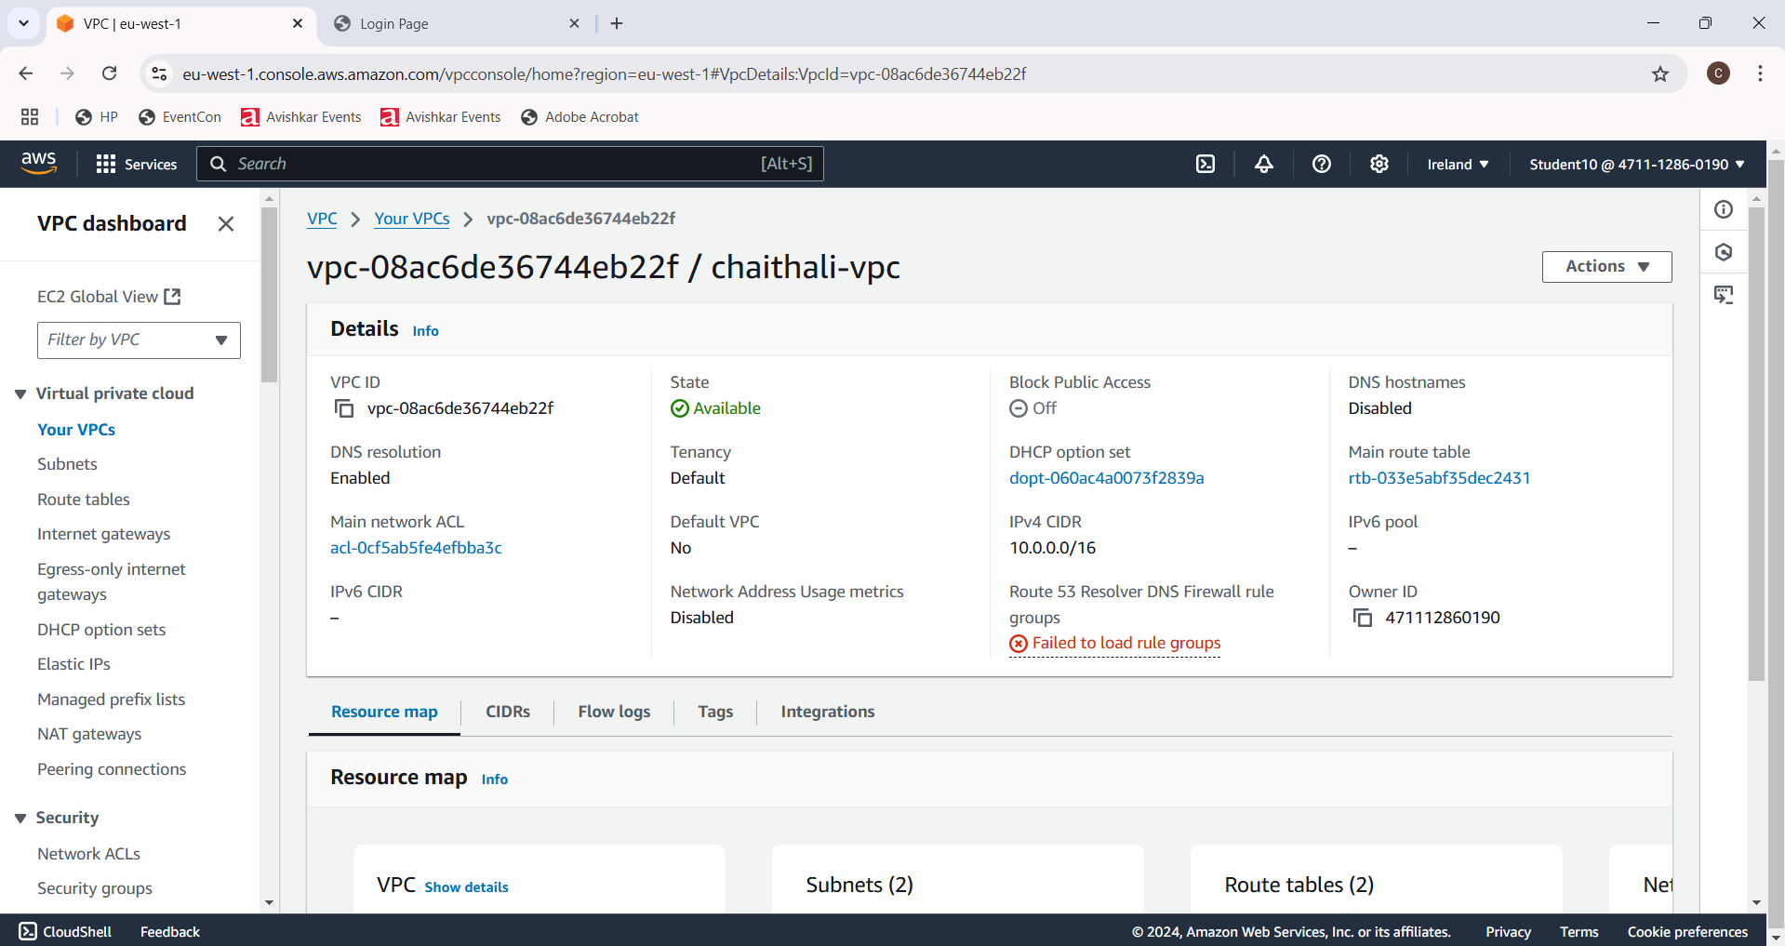

**Internet Gateway:**

**Steps:**

**1. In VPC dashboard, click on Internet Gateway.**

**2. To create Internet gateway, click on create Internet Gateway.**

**3. Then give name as chaithali-igw and click on create Internet Gateway.**

**4. Your internet Gateway is created.**

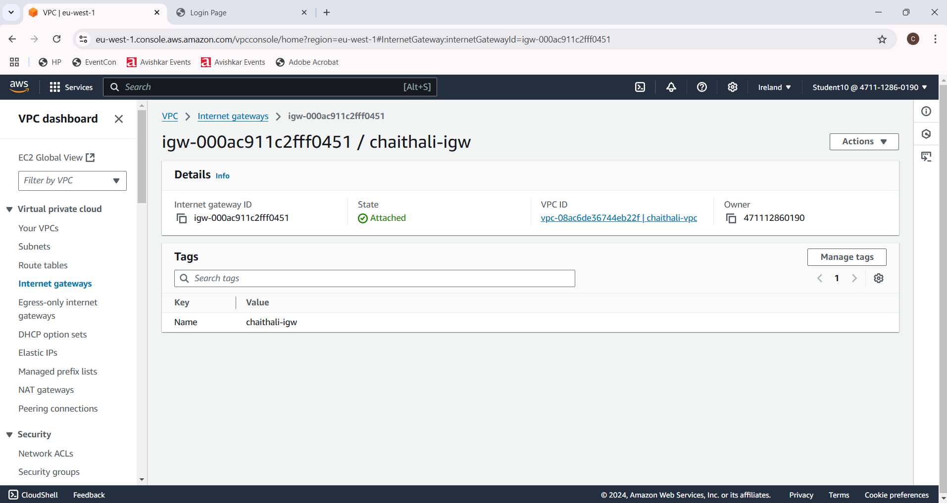

**Public Subnet 1:**

**Steps:**

**1. To create subnet, go to VPC dashboard under virtual private cloud, click on subnet.**

**2. Select the vpc you have already created and in subnet setting, give subnet name as chaithali-subnet1.**

**3. Then choose availability zone as region you have selected before creating the vpc and IPv4 subnet CIDR block as 10.0.1.0/25.**

**4. Then create one more subnet as following subnet but give name as chaithali-subnet2 and then choose availability zone and IPv4 subnet CIDR block as 10.0.2.0/25.**

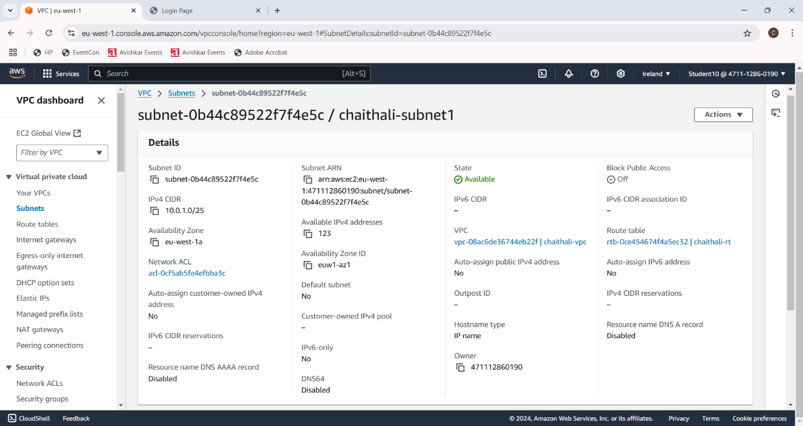

**Public Subnet2:**

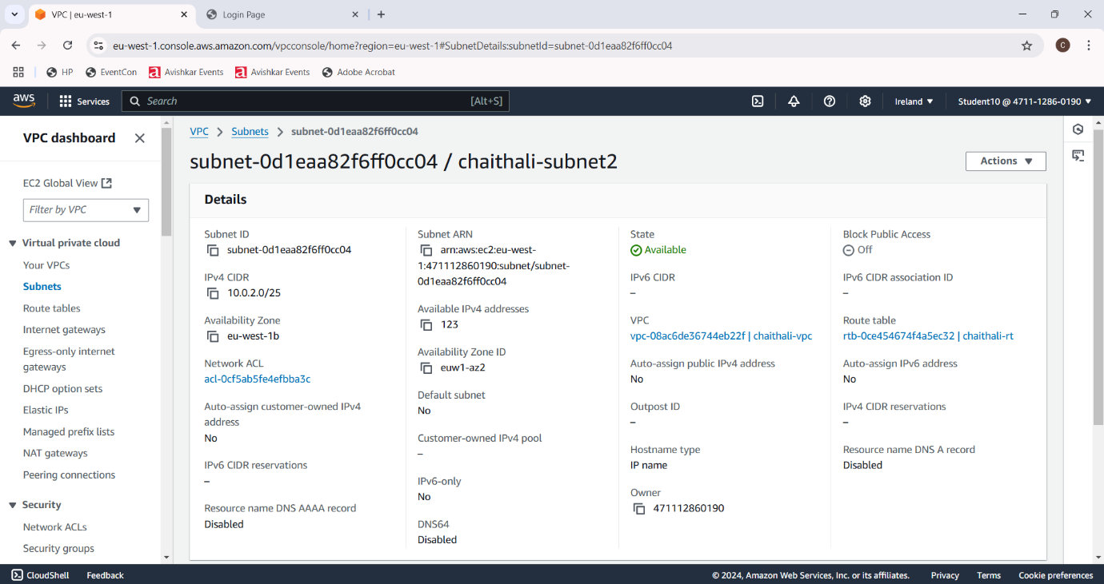

**Router Table:**

**Steps:**

**1. To create Route table, click on create route table.**

**2. In route table setting, give route table name as chaithali-rt and select vpc that is created.**

**3. Then click on create route table.**

**4. After route table is created, go to routes and click on edit route and then click on add route.**

**5. Then in destination, select 0.0.0.0/0 as destination and target as Internet Gateways.**

**6. After selecting internet gateway, it allows to select the igw- and select the internet gateway that is created by you.**

**7. At last, click on save changes.**

**8. Then go to subnet association and click on edit subnet association.**

**9. Select the subnet you have created and click on save changes.**

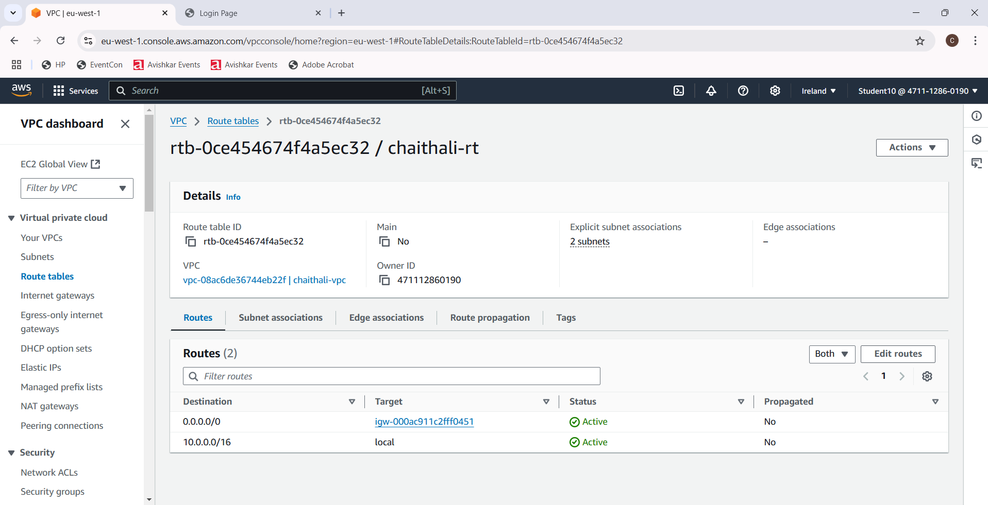

**E2C Instance:**

**Steps:**

**1. Go to EC2 in AWS console and click on instances.**

**2. Click on launch instance and give the name for the instances as chaithali-server.**

**3. After giving name to instances, select application and OS Images as Amazon Linux and instances type as t2.micro .**

**4. In keypair, click on create keypair and give keypair name as chaithali-keypair and click on create keypair. The keypair is created.**

**5. Then in network setting, click edit. Select vpc and subnet and also assign public IP as enable.**

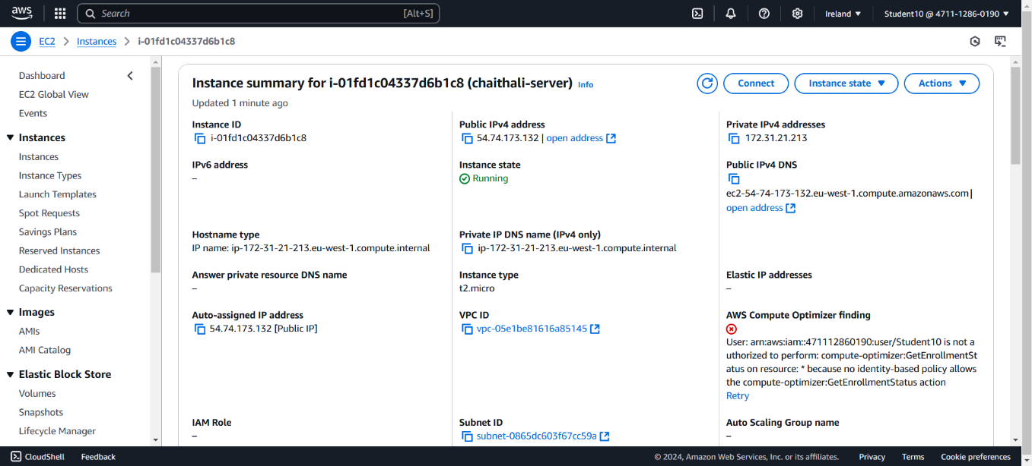

**Connection:**

**Steps:**

**1. Select the instance you have created and click on connect.**

**2. Go to SSH client. Copy the example.**

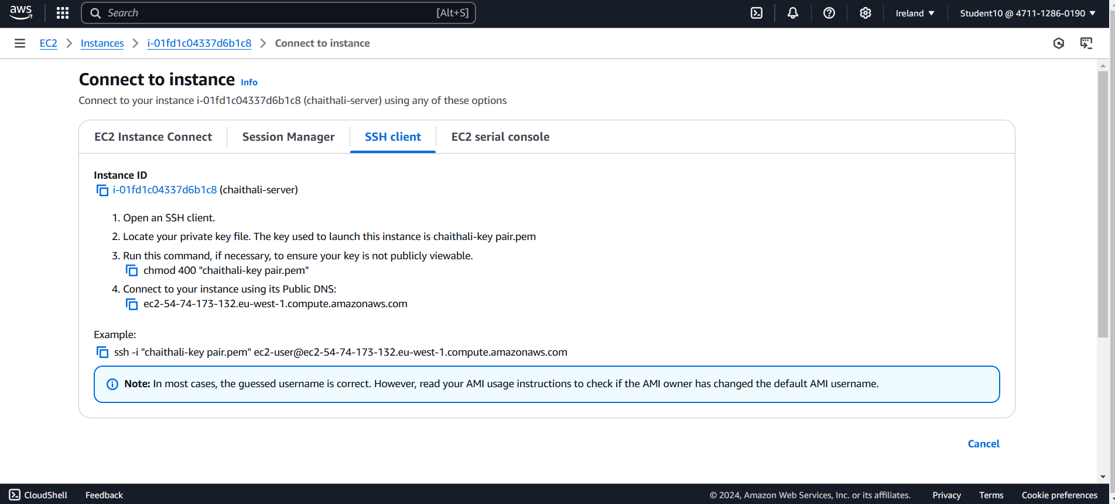

**Command Prompt:**

**Steps:**

**1. Go to command prompt and follow the following the commands:**

**• Cd Downloads**

**• Paste the SSH client example.**

**• Yow will get to confirm the connecting, type yes.**

**• Then type sudo su and cd.**

**• Then type yum install httpd -y.**

**• After installation, type cd /var/www/html.**

**• Then type vi index.html and vi editor will get opened and press i to insert the content.**

**• After that, press esc and: wq to save the content.**

**• Go to instances, copy the public ip and paste on browser url.**

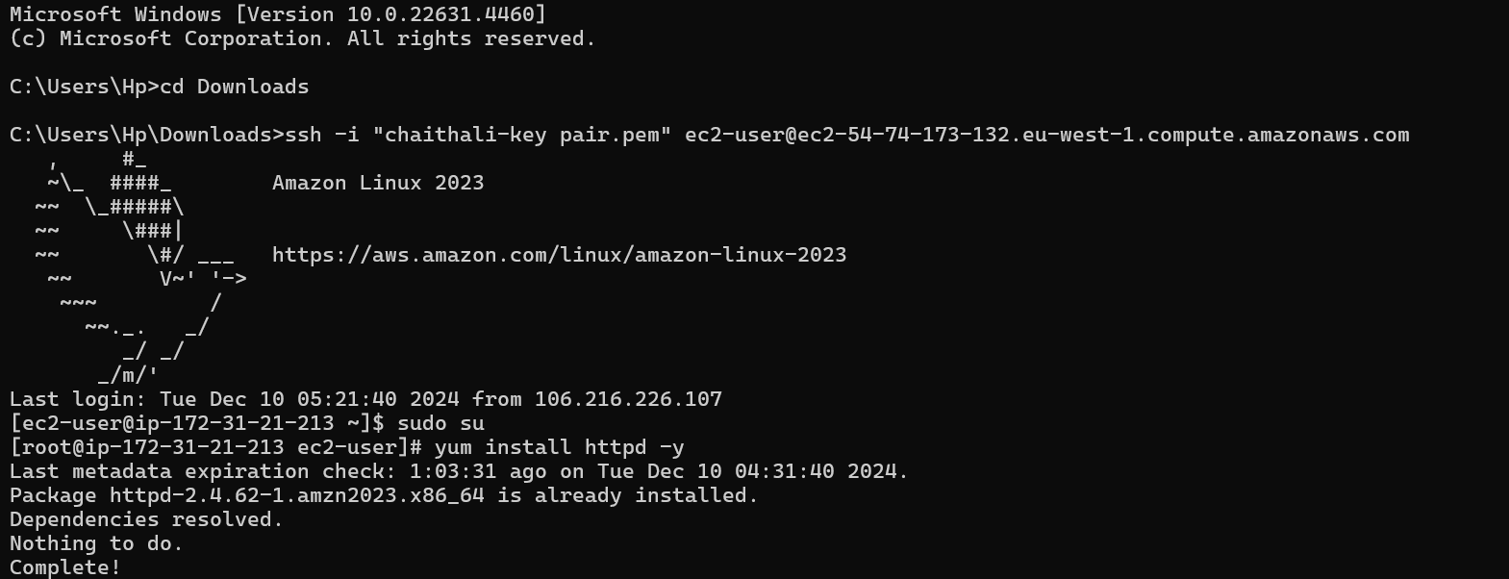

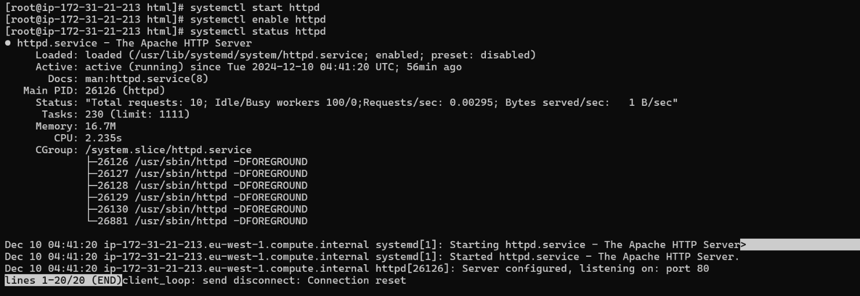

**Final Result:**

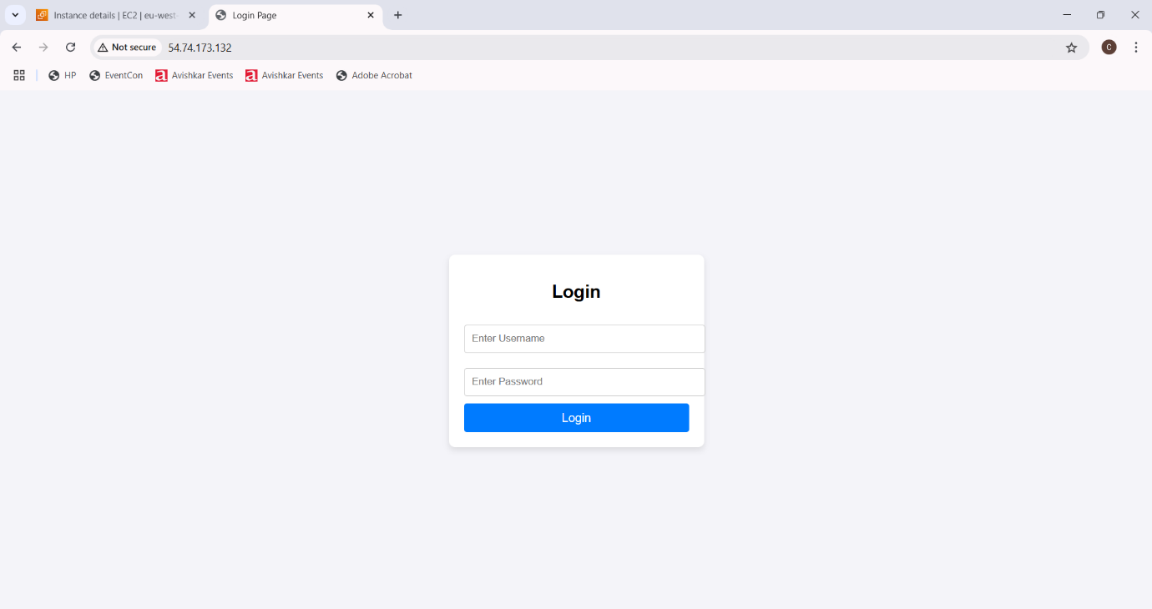

**Project 2: How to create new instance using AMI**

**Creating Image:**

**Steps:**

1. **To create image using AMI, go to EC2 and click on instances.**
2. **Select the instance that is created before and click on action.**
3. **In action, select image and template. In image and template, select create images.**
4. **Give name as anu-server-backup and description to the instances.**

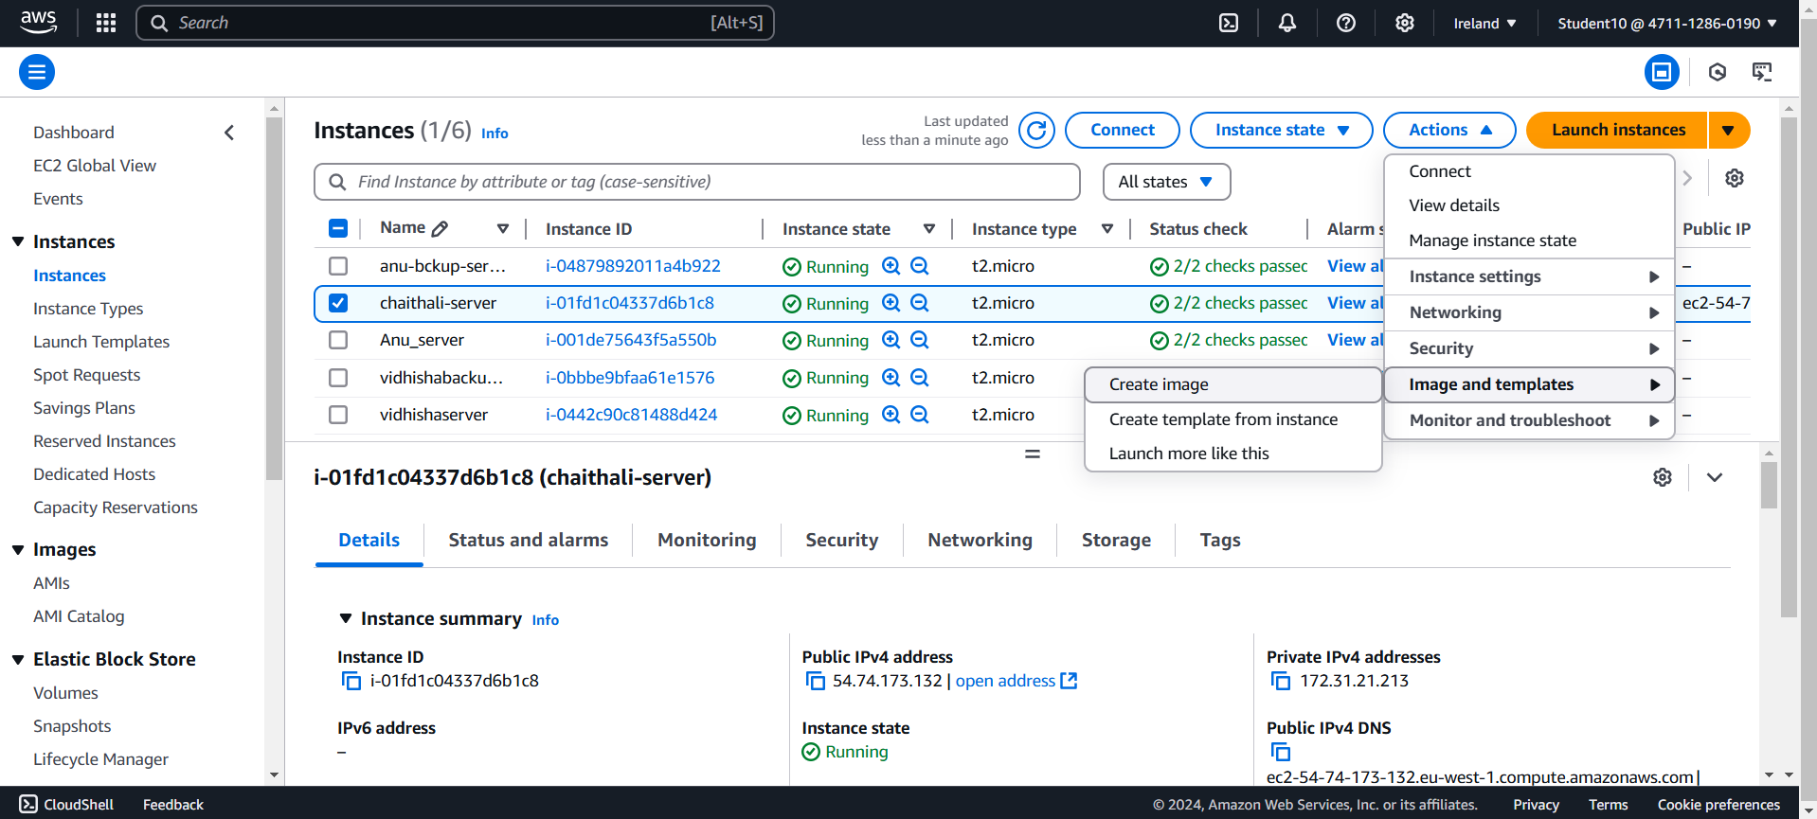

**AMI Summary:**

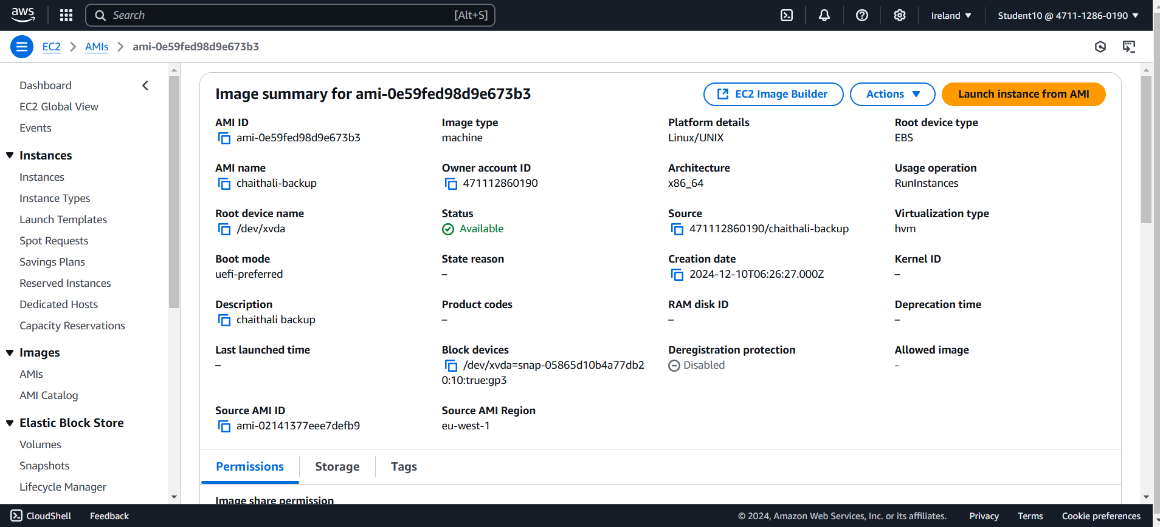

**After Launching the Backup Server:**

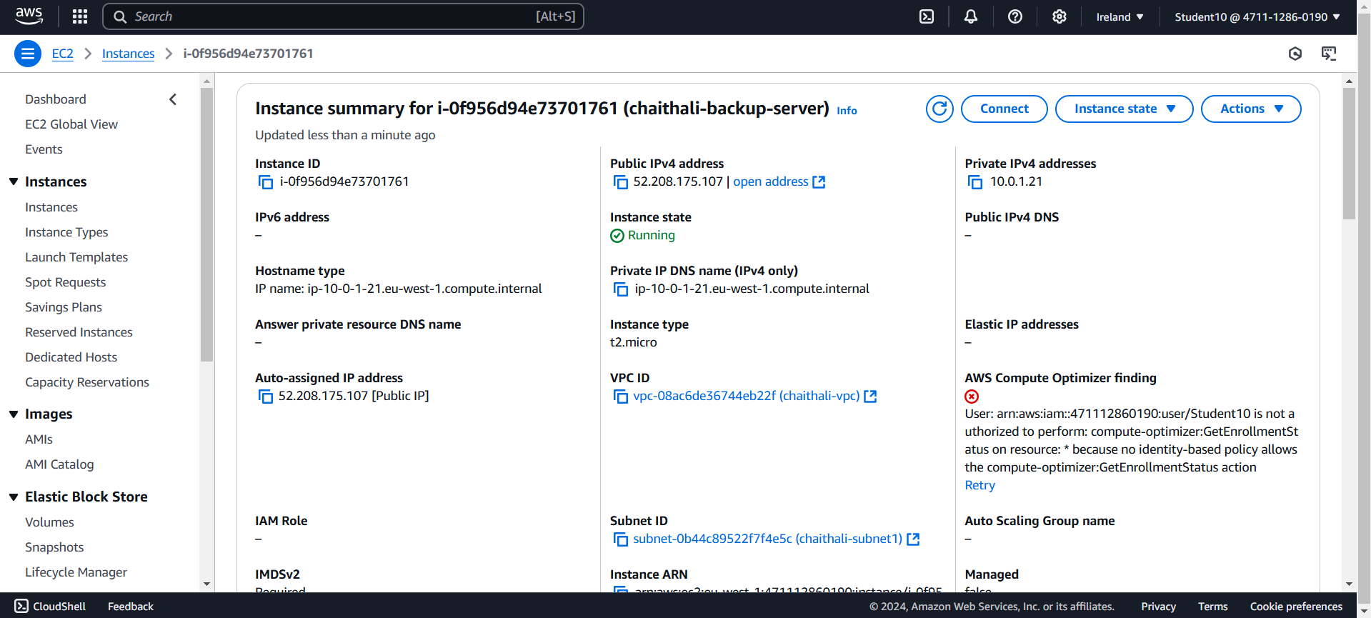

**Final Result:**

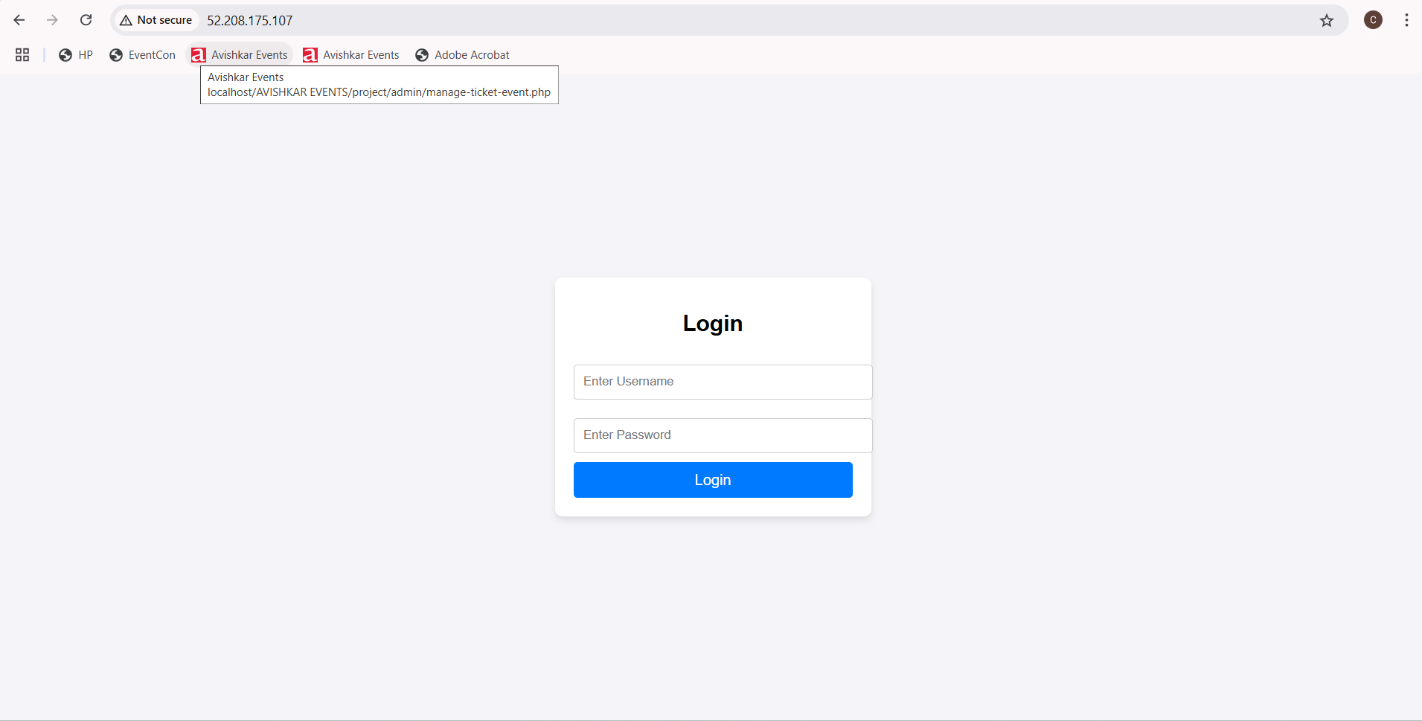

**Project 3: How to Connect Private Server to Internet using NAT Gateway (Jump Server/Bastion Host)**

**Virtual Private Cloud:**

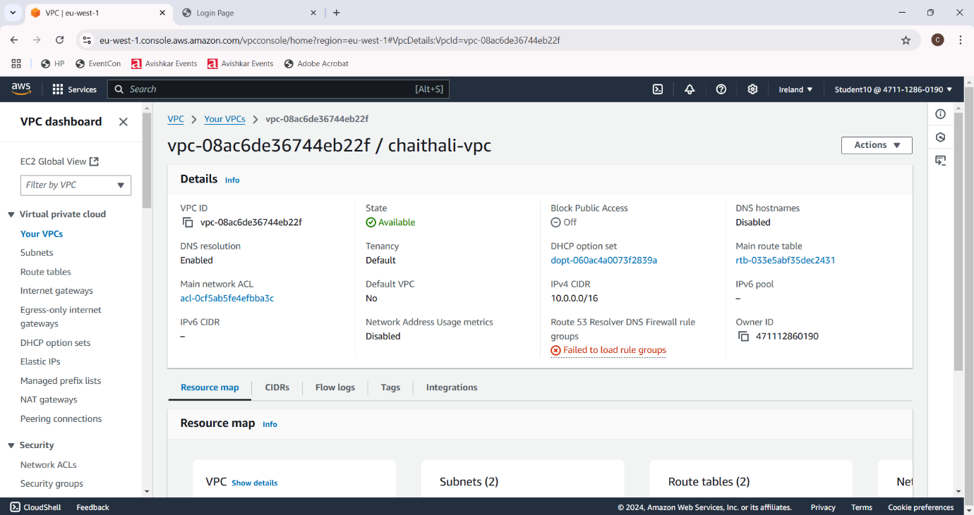

**Internet Gateway:**

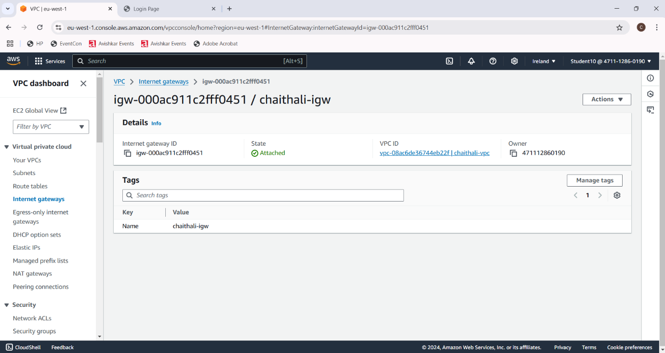

**Public Subnet1:**

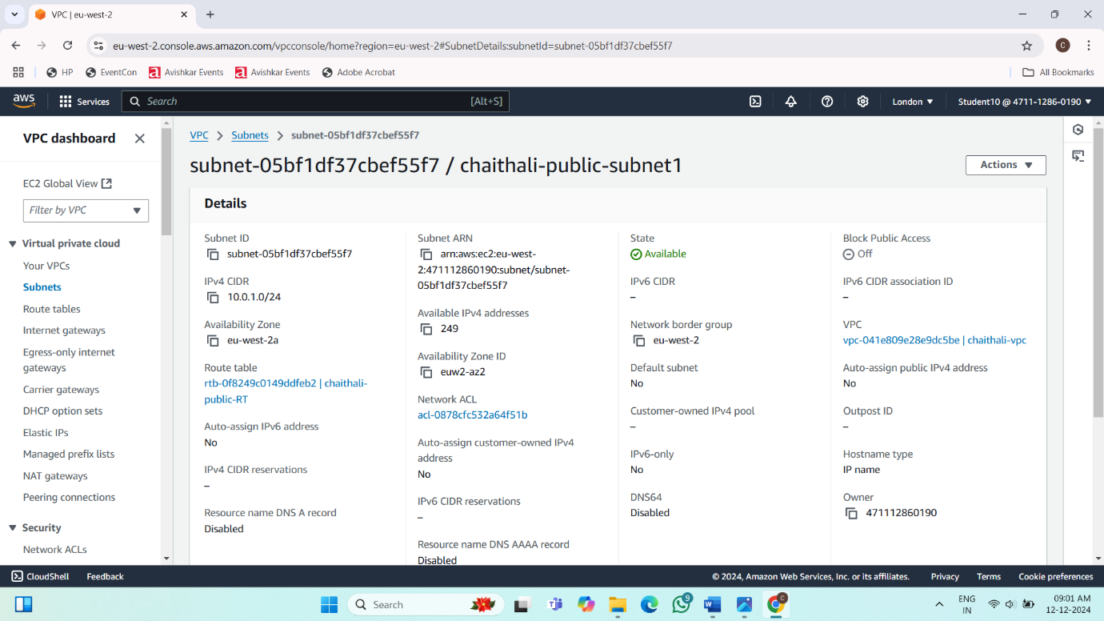

**Public Subnet2:**

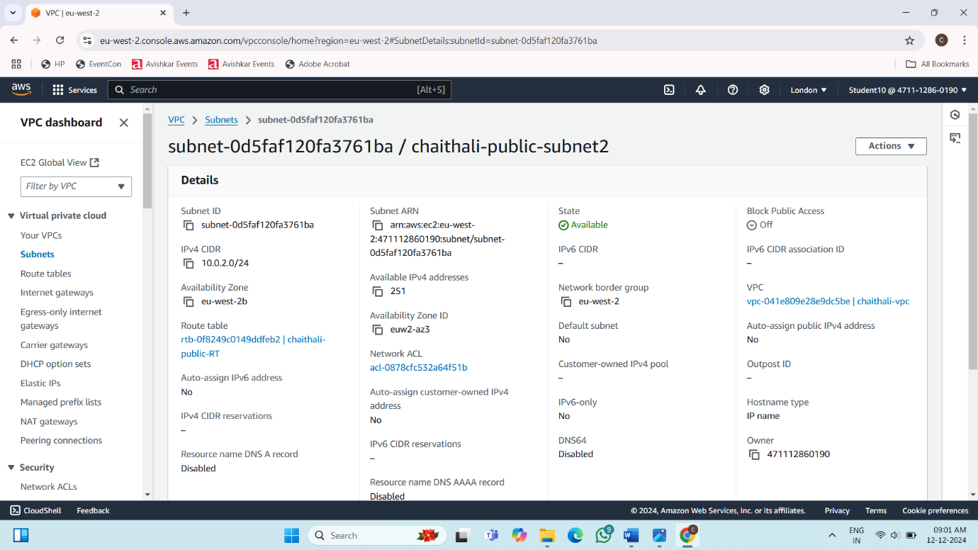

**Private Subnet1:**

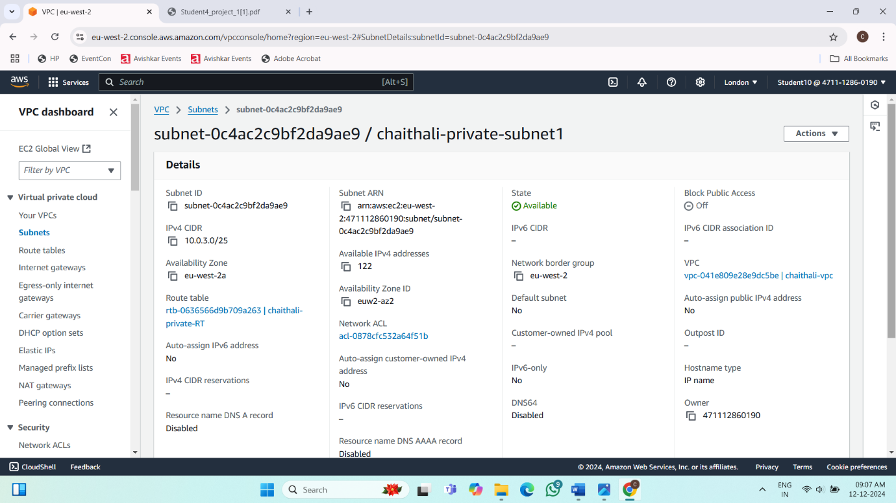

**Private Subnet2:**

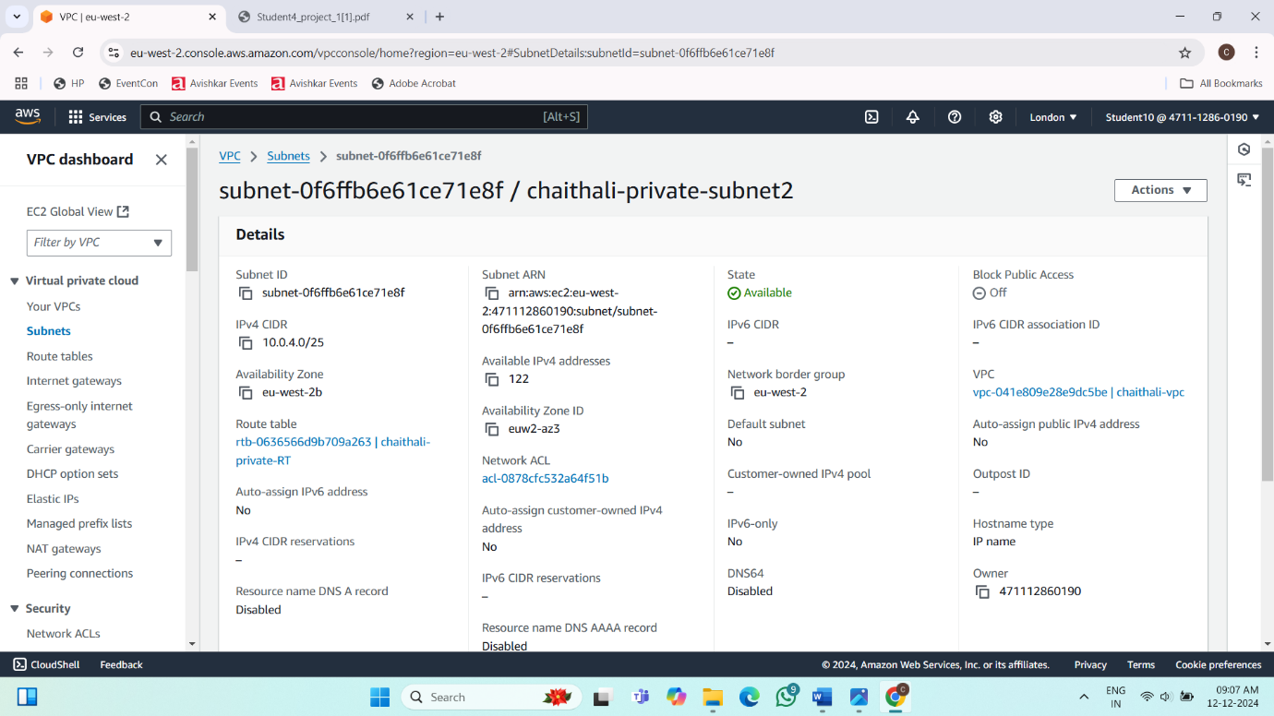

**Public Route Table:**

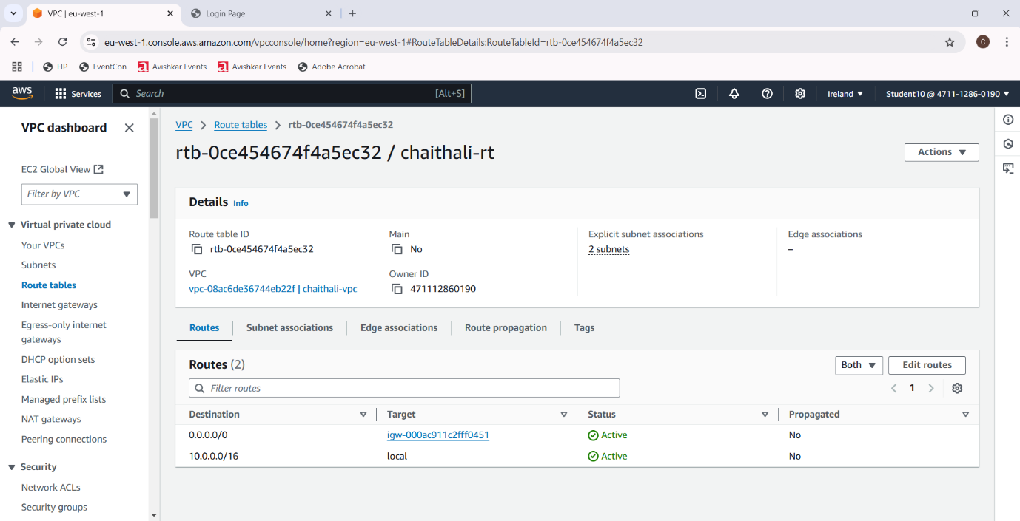

**Private Route Table:**

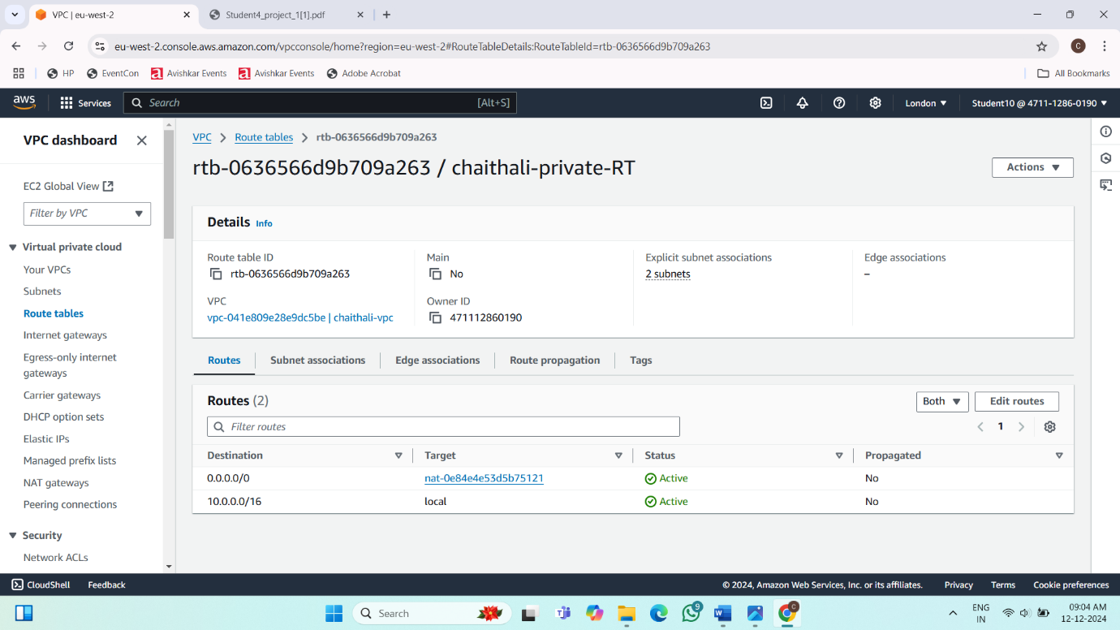

**NAT Gateway:**

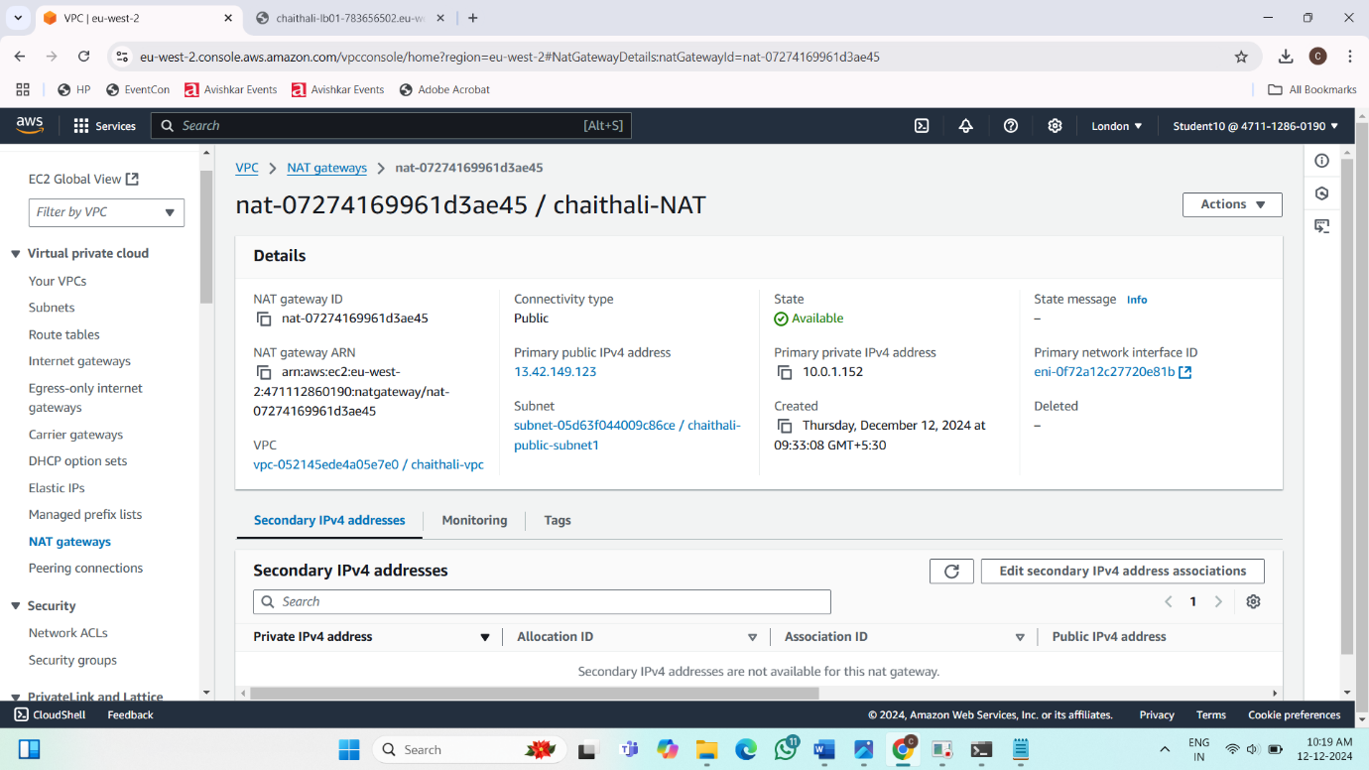

**Instances:**

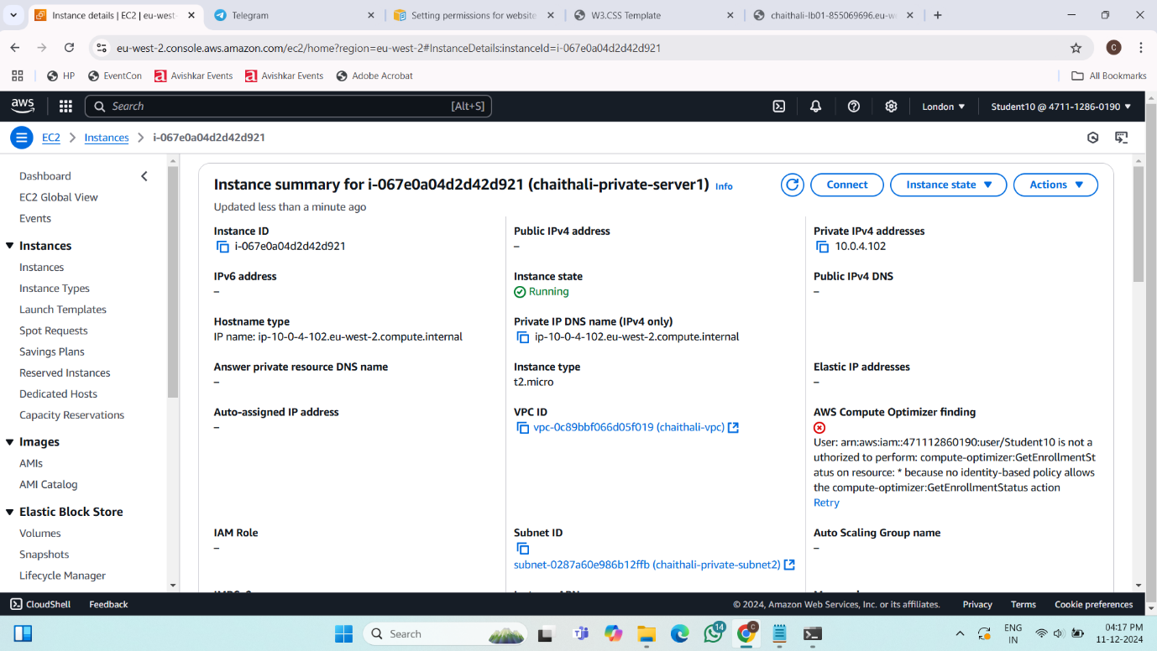

**Final Result:**

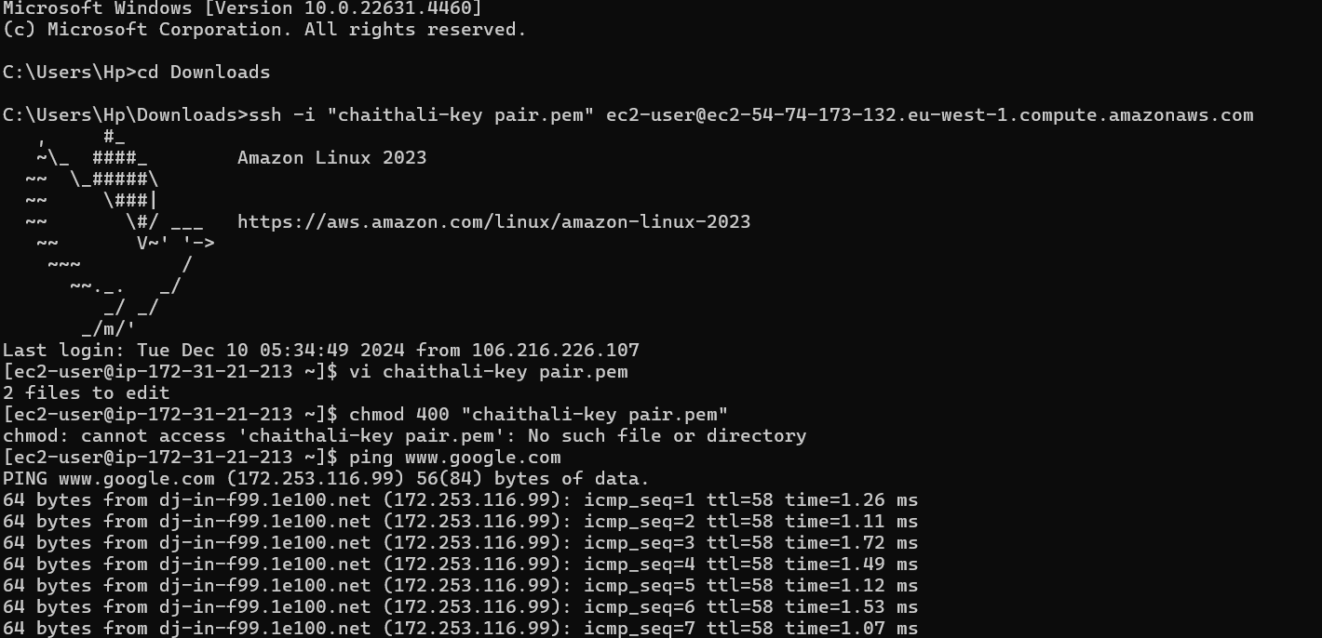

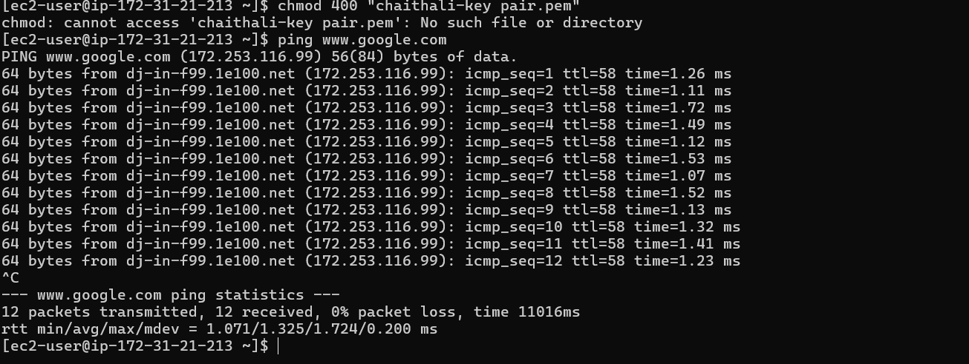

**Project 4: Hosting a static website using S3 Bucket**

**S3 bucket**

**Steps:**

**1. Go to search bar and type s3. Click on s3.**

**2. In S3 dashboard, go to general purpose buckets and click on create bucket button.**

**3. In general configuration, select bucket type as general purpose and give name as anusha04.**

**4. Click on create bucket button. Your bucket is created.**

**Uploading a file:**

**Steps: 1.**

**Click on created bucket.**

**2. Bucket window gets opened and click on upload button.**

**3. In upload window, select files and folders and click on add files and select the file you want to add.**

**4. Then click on upload. Your file is uploaded**

**Static website hosting:**

**Steps:**

1. **Select the properties, go to static website hosting and click on edit.**
2. **Give index document name as file name that is dailyping.html and click on save changes button.**

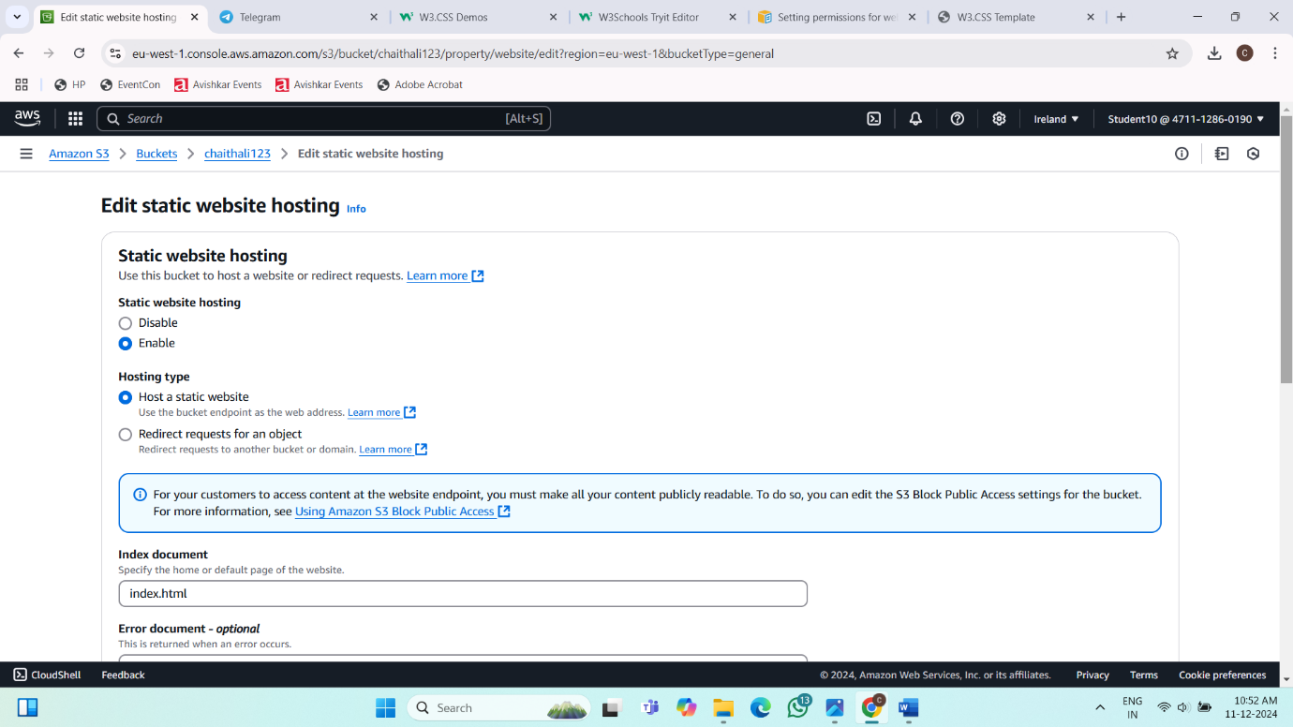

**Bucket setting:**

**Steps:**

1. **Go to permission, select block public access and click on edit.**
2. **Under block public access (bucket setting), uncheck the block all public access and click on save changes button.**

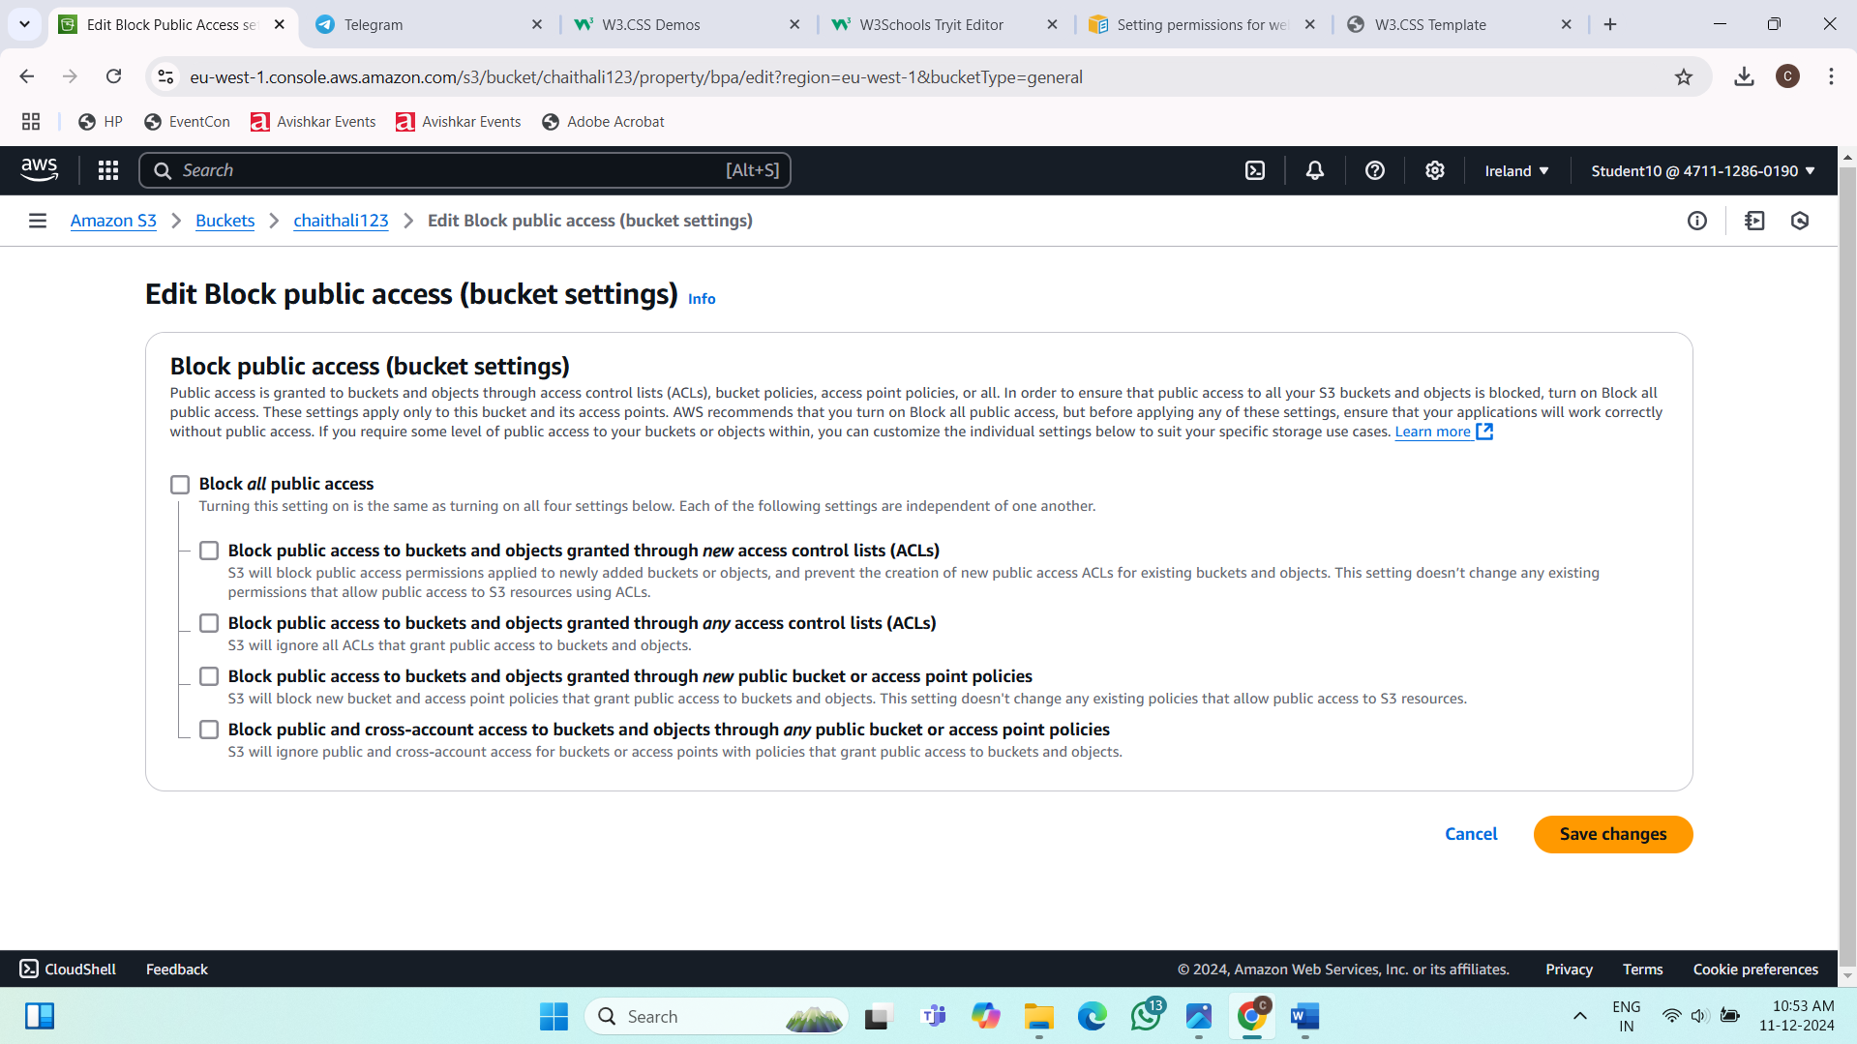

**Setting permission for website access and add bucket policy:**

**Steps:**

1. **Go to google browser and type bucket policy for static website.**
2. **You will get setting permission for website access and click on it.**
3. **You will get add a bucket policy and copy the code from the editor.**

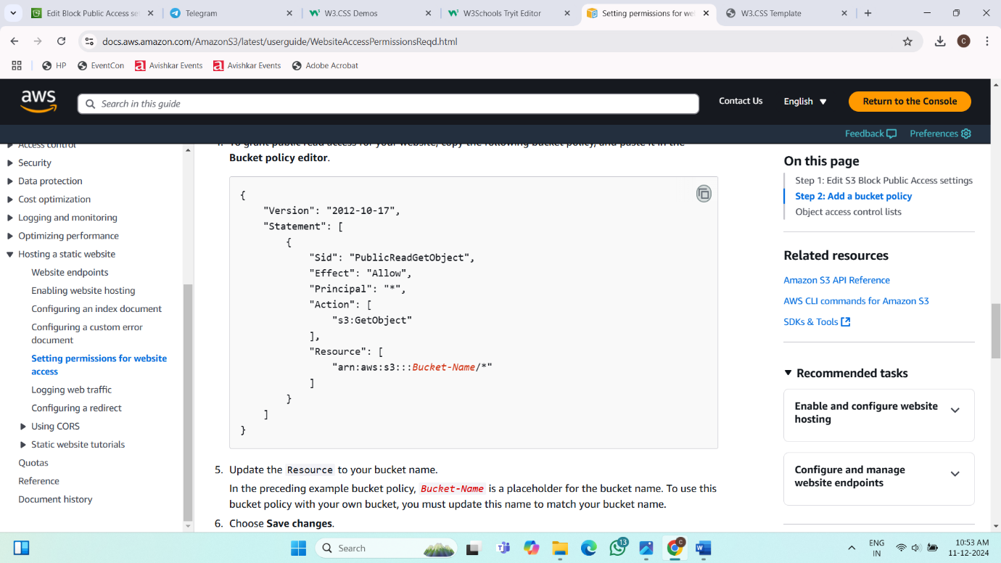

**Bucket policy:**

**Steps:**

1. **In permission, select bucket policy and click on edit.**
2. **Paste the code copied from the editor and change the ‘Bucket-Name’ as chaithali123 (created bucket name).**

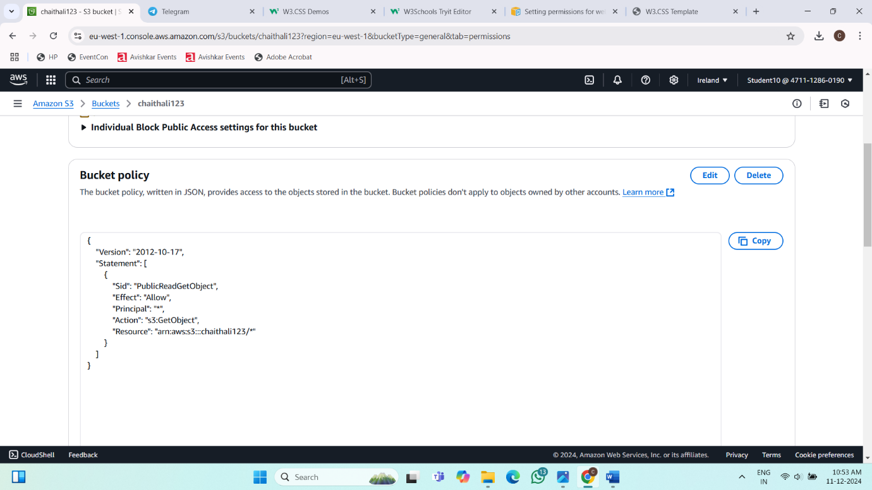

**Static website hosting url:**

**Steps:**

1. **In properties, under static website hosting, copy the bucket website endpoint url and paste it on google browser.**

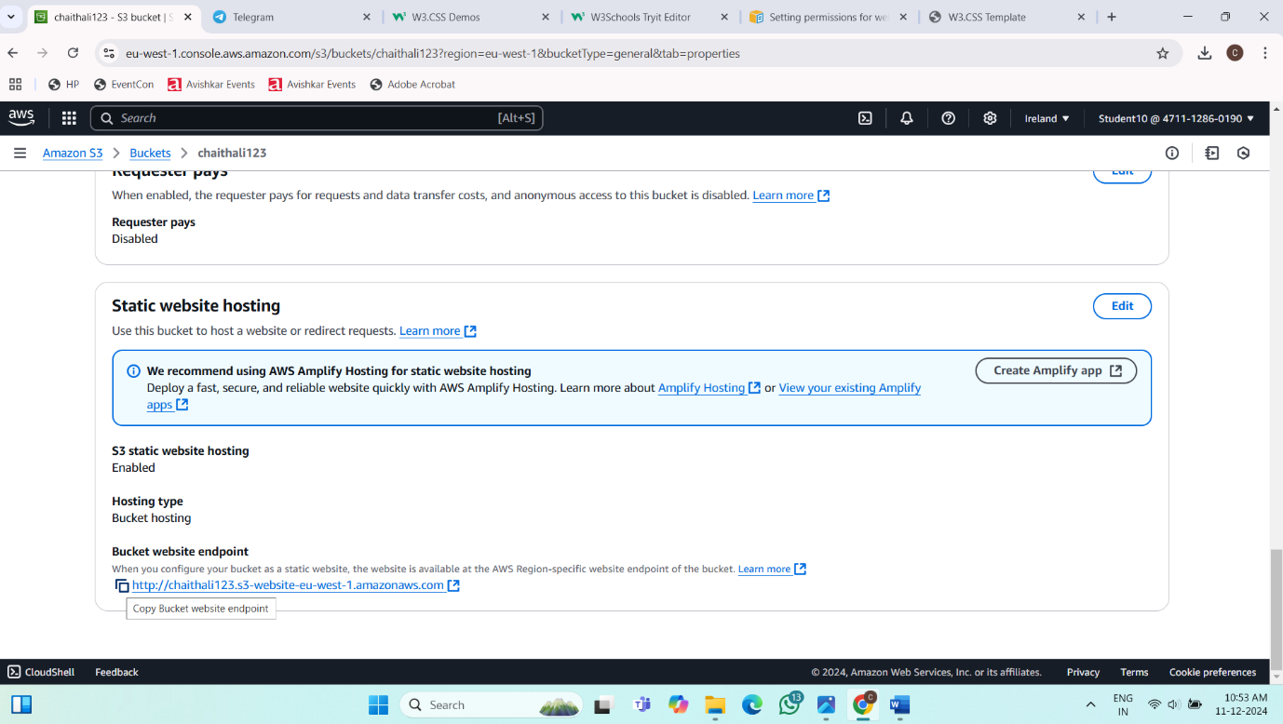

**Final Result:**

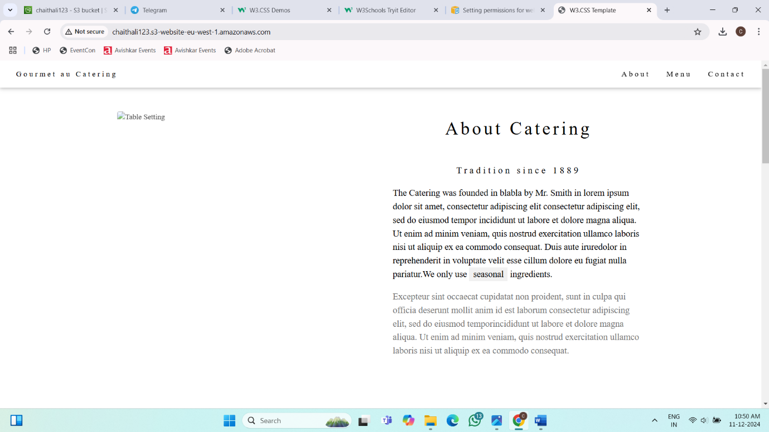

**Project 5: Launching the Website using Load Balancer DNS Name**

**VPC:**

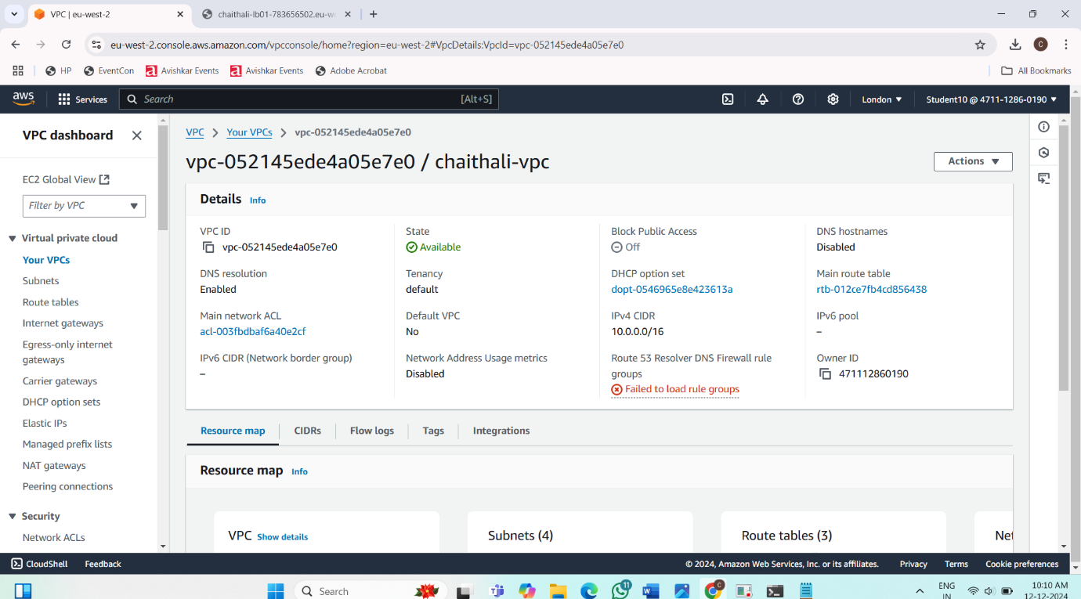

**Internet Gateway:**

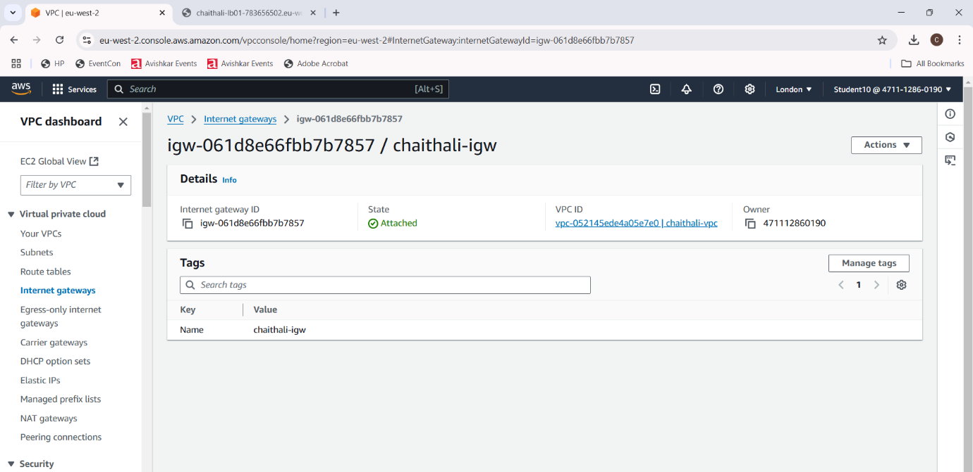

**Public Subnet1:**

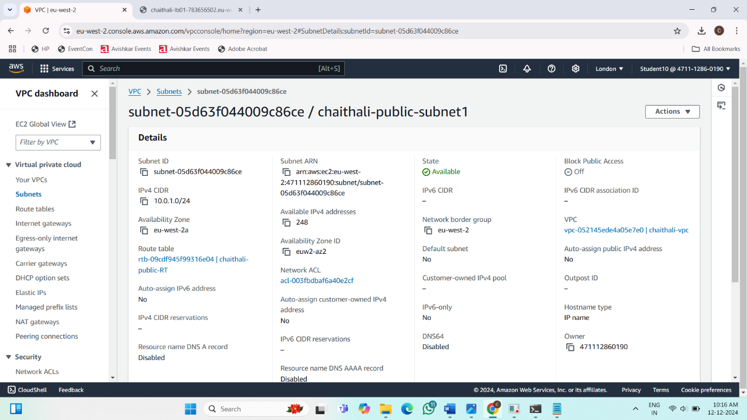

**Public Subnet2:**

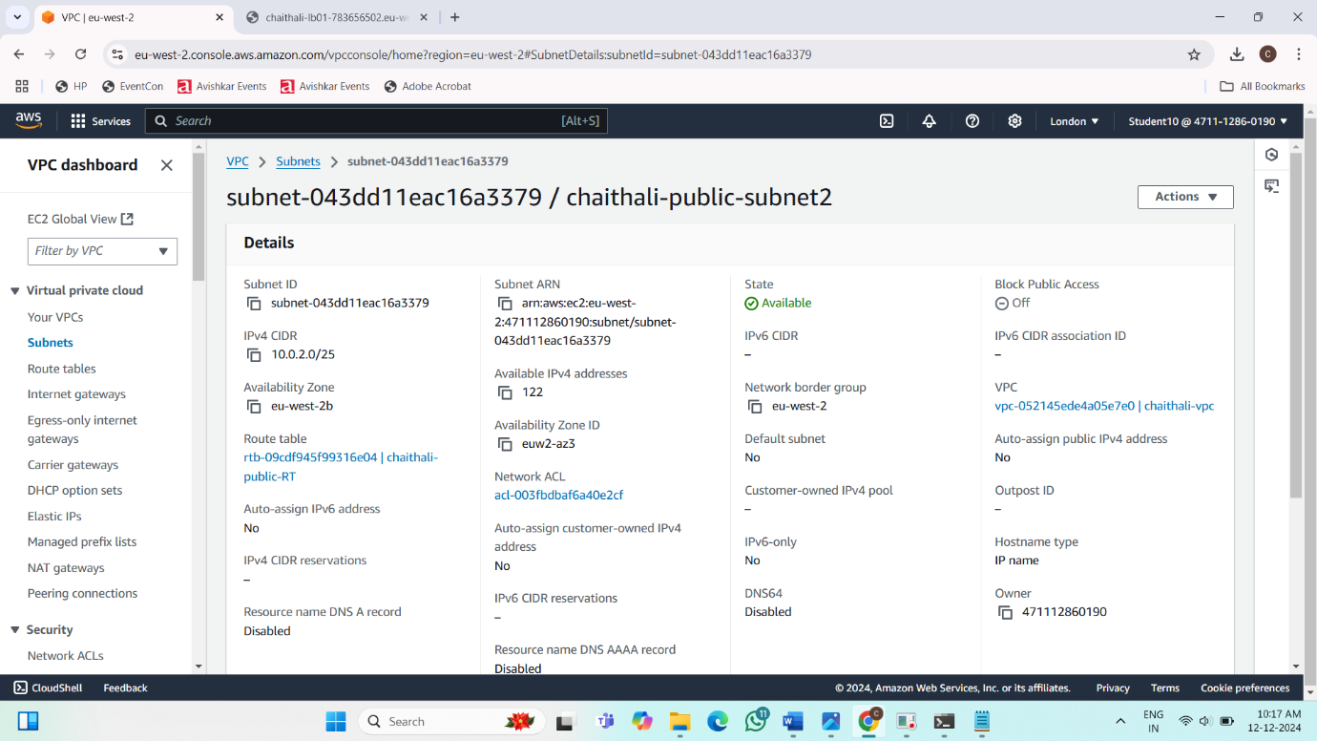

**Private Subnet1:**

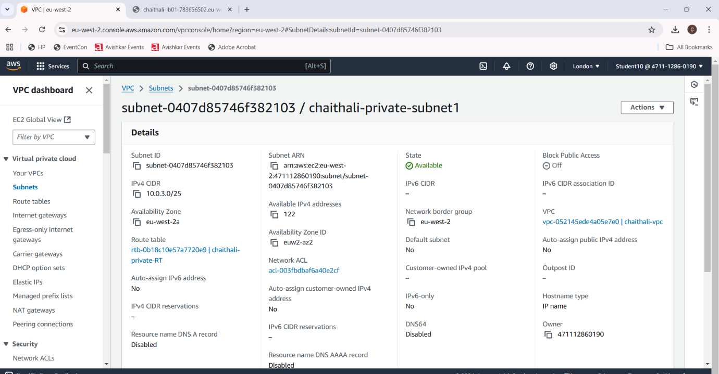

**Private Subnet2:**



**Private Route Table:**

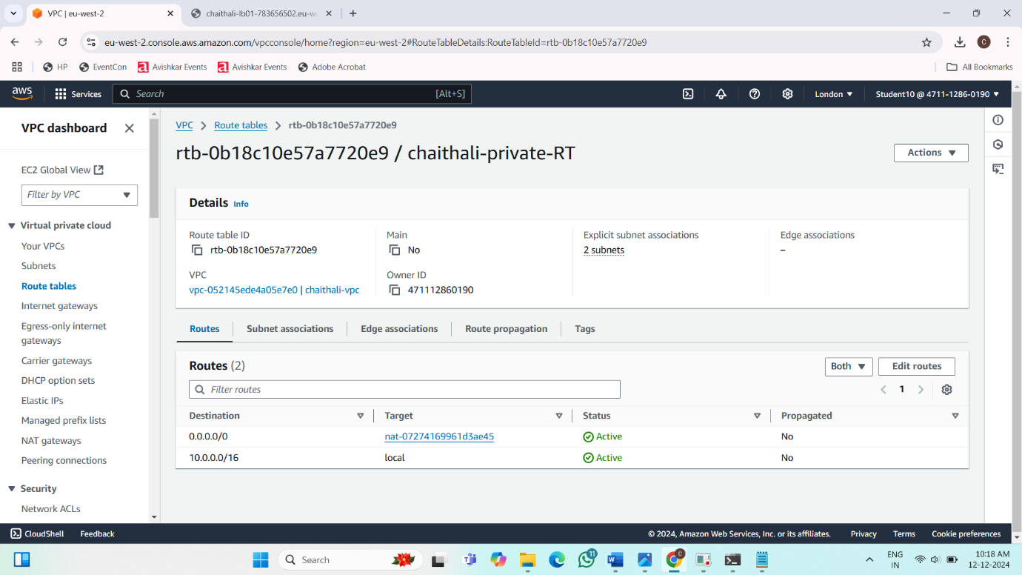

**Public Route Table:**

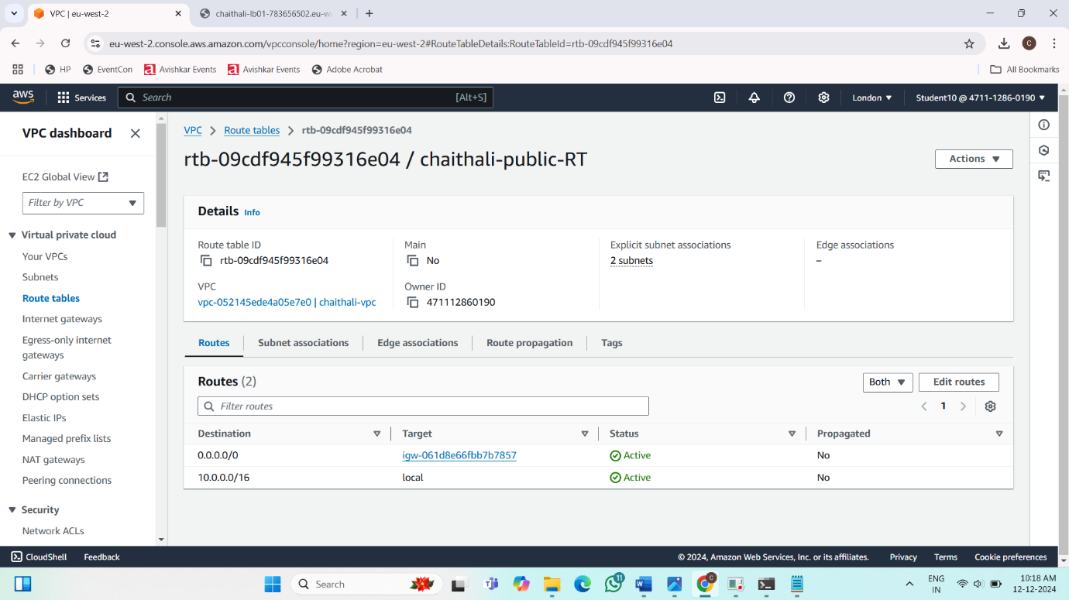

**NAT Gateway:**



**Instances:**

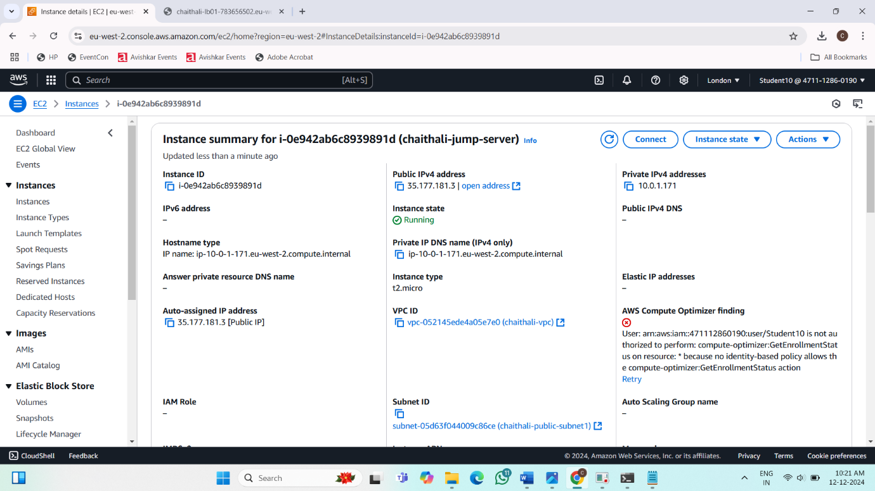

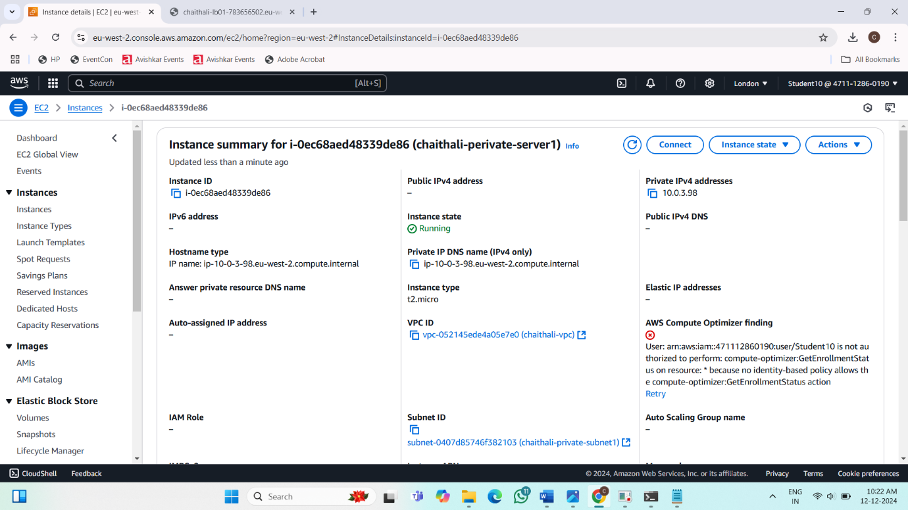

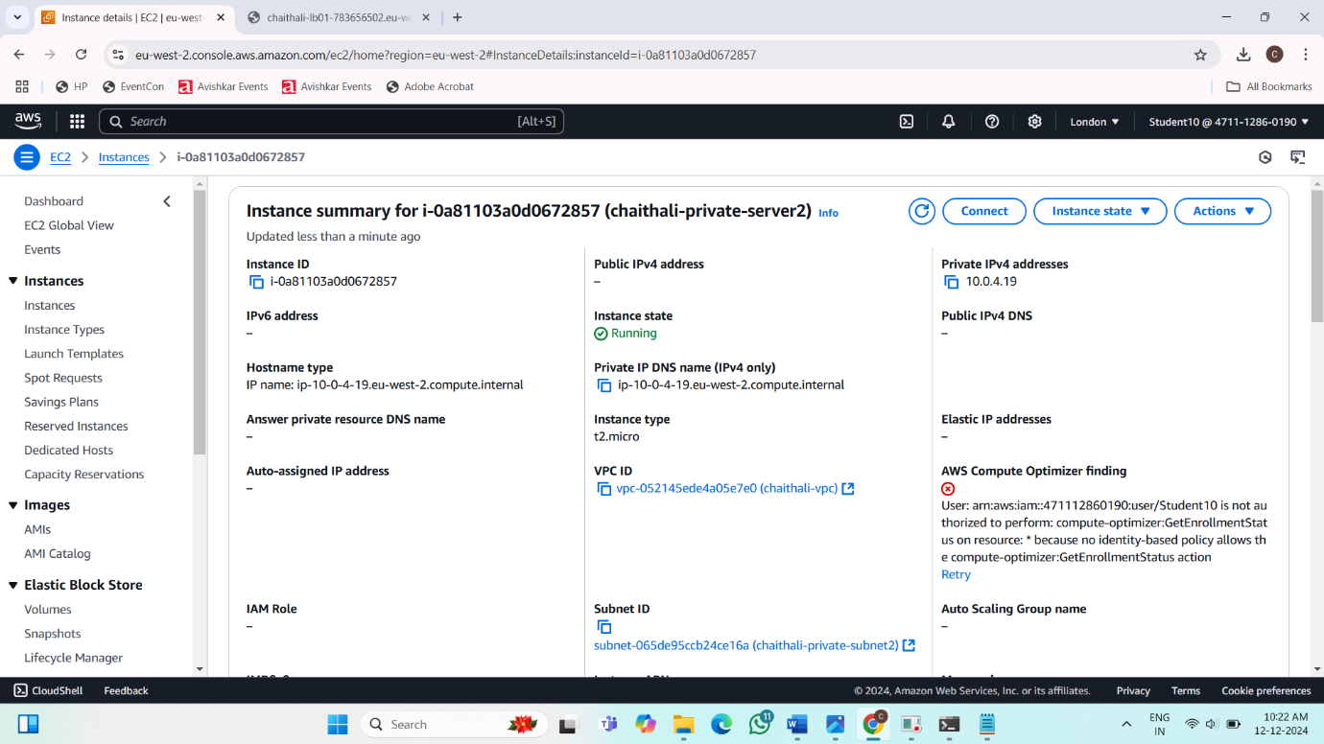

**Load Balancer:**

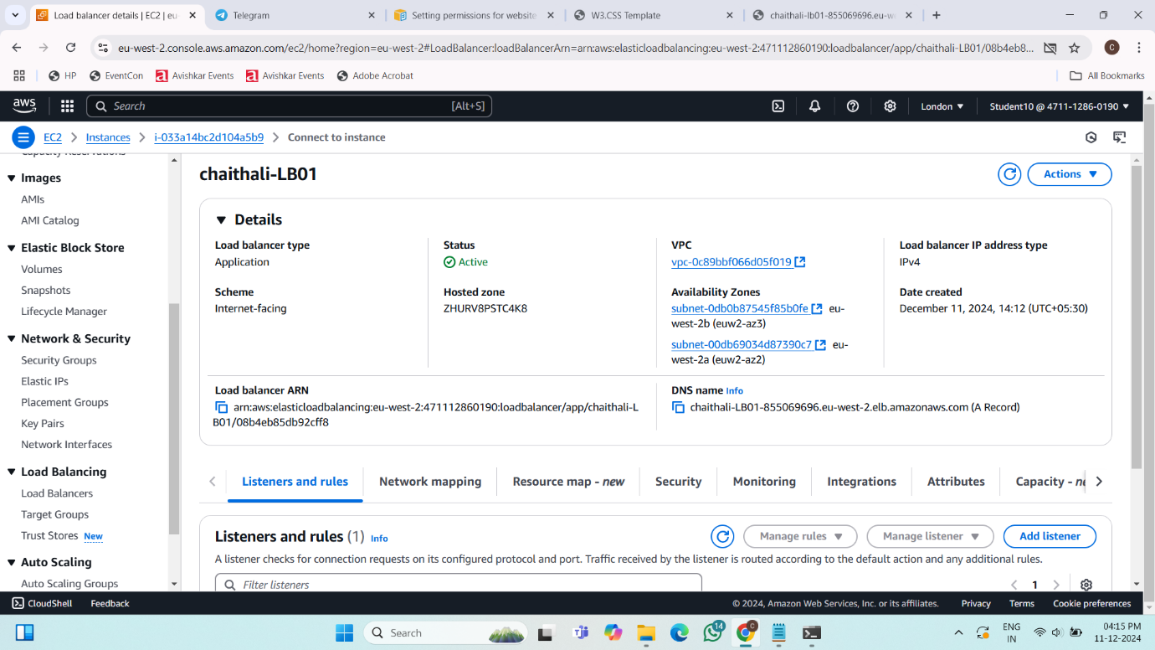

**Target Group:**

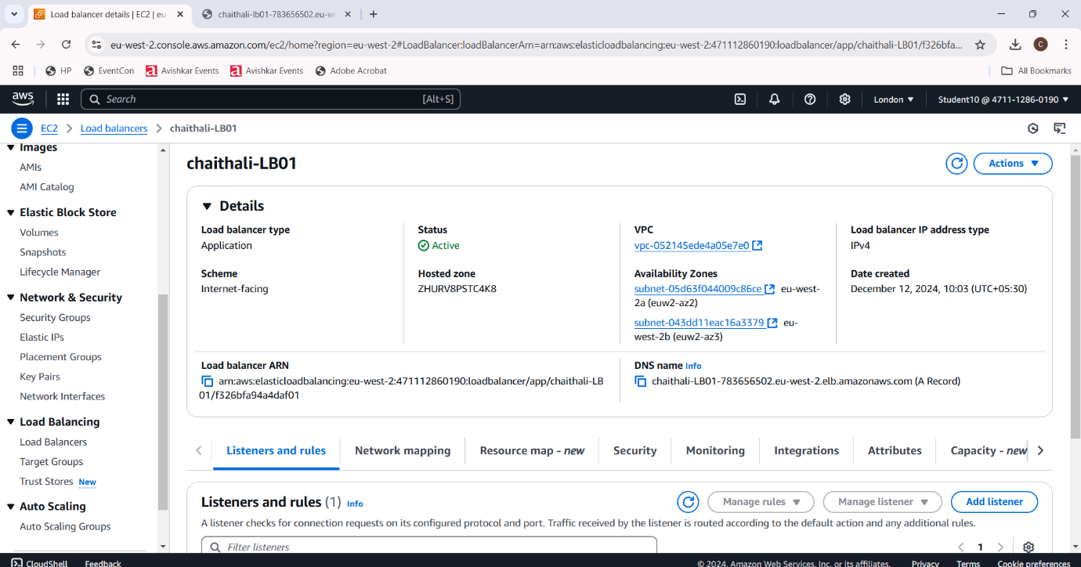

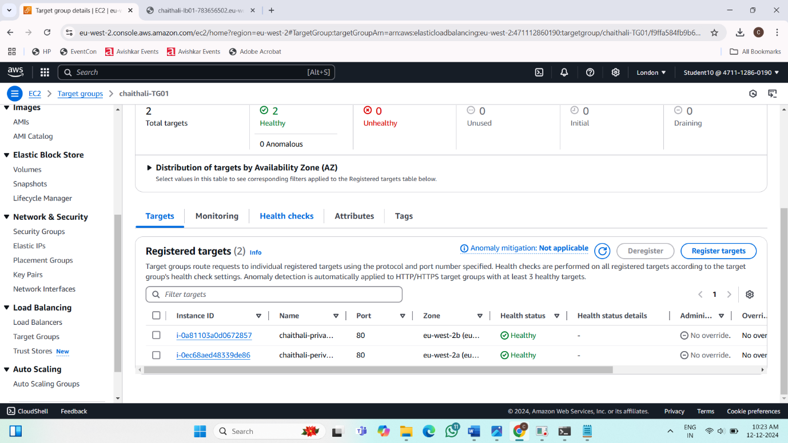

**Final Result:**

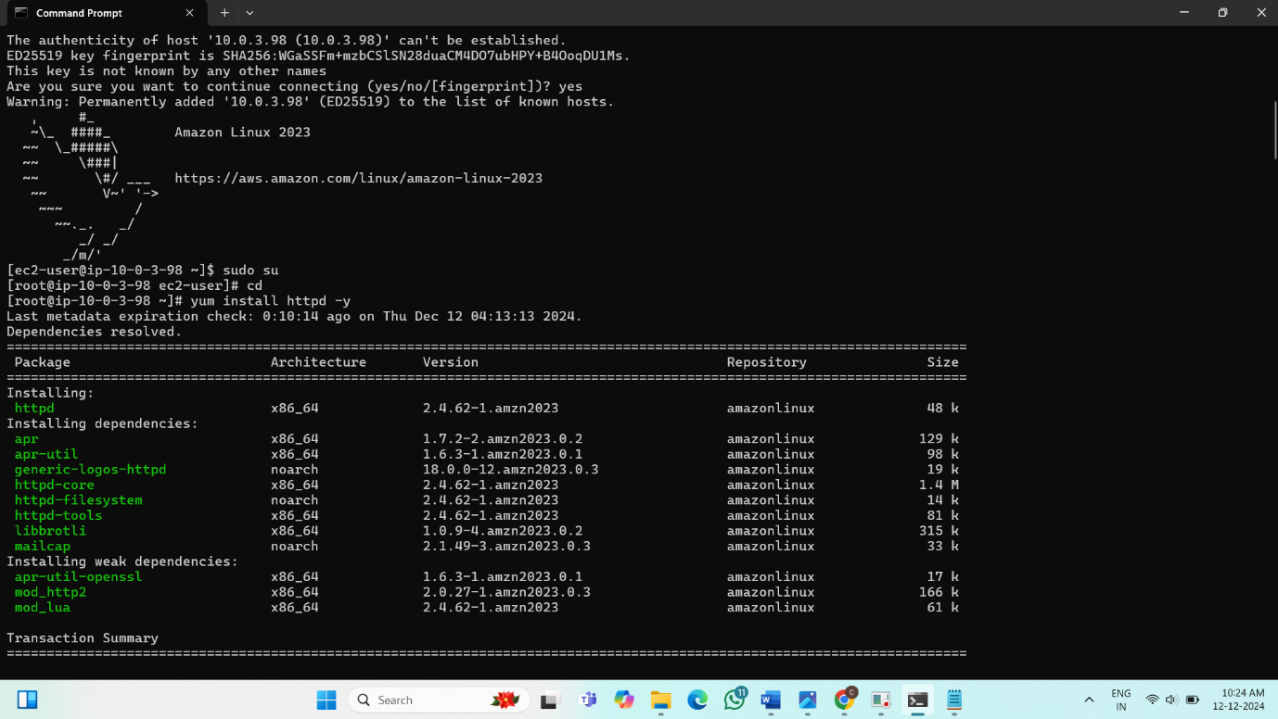

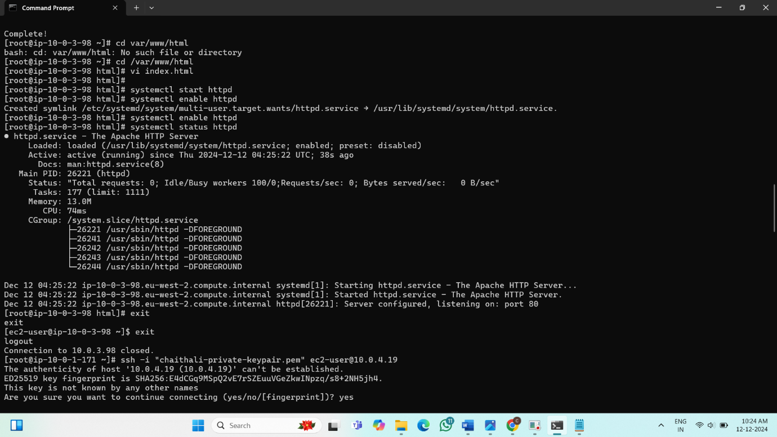

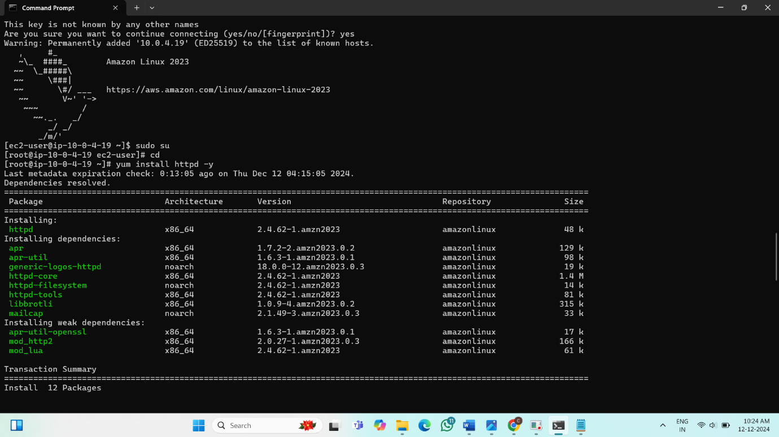

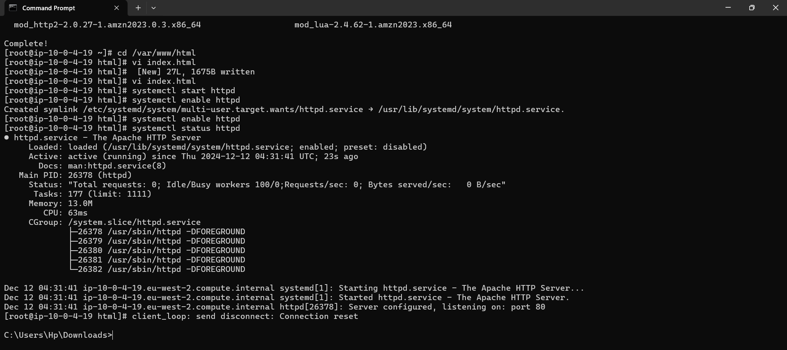

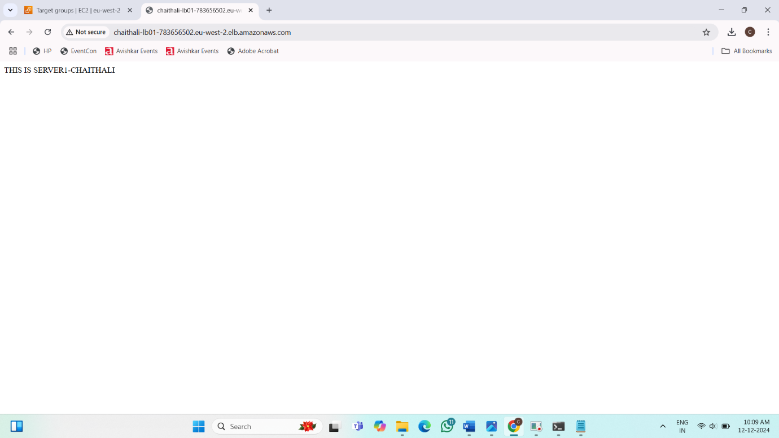

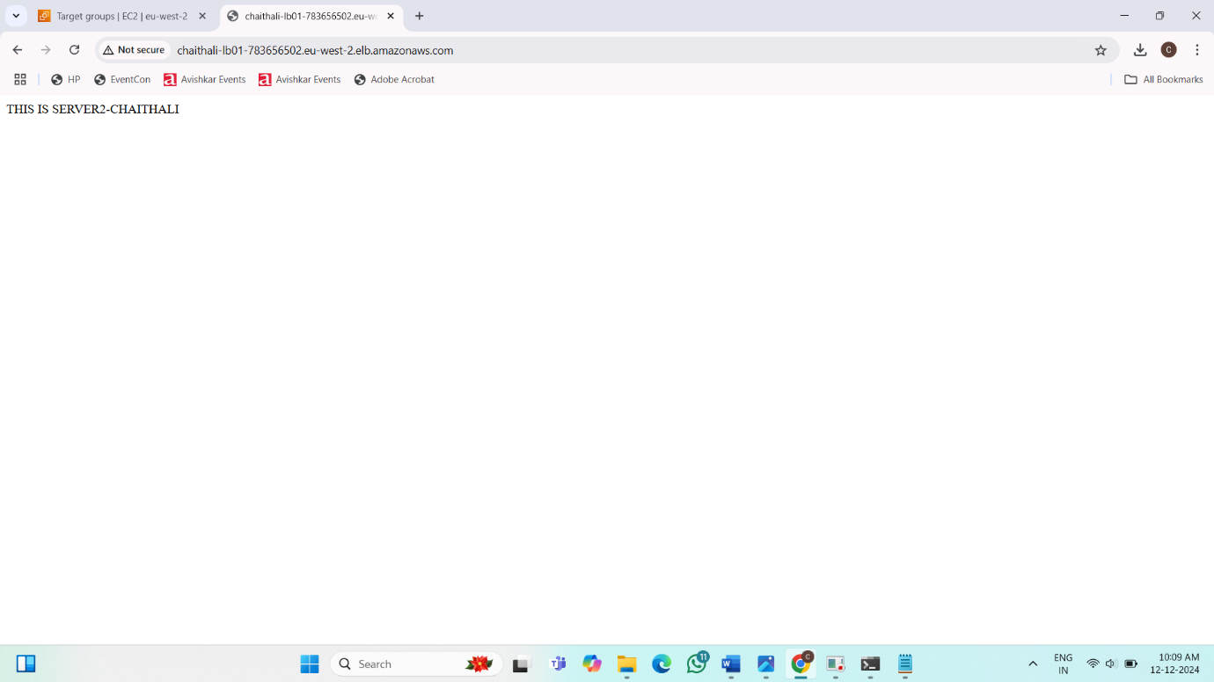

**Project 6: How to create a Repository in GitHub**

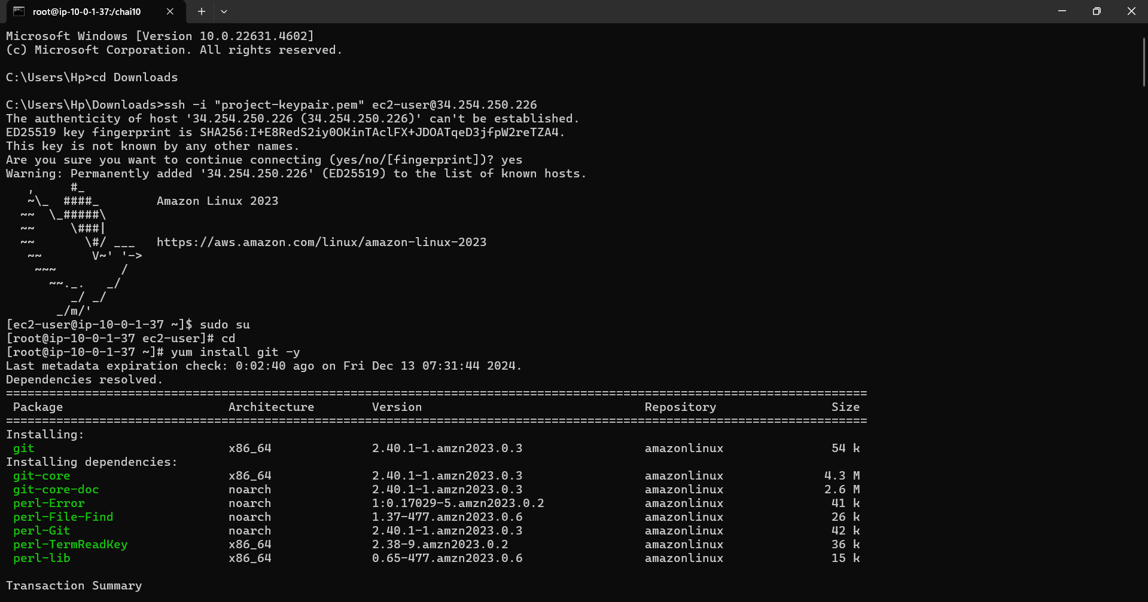

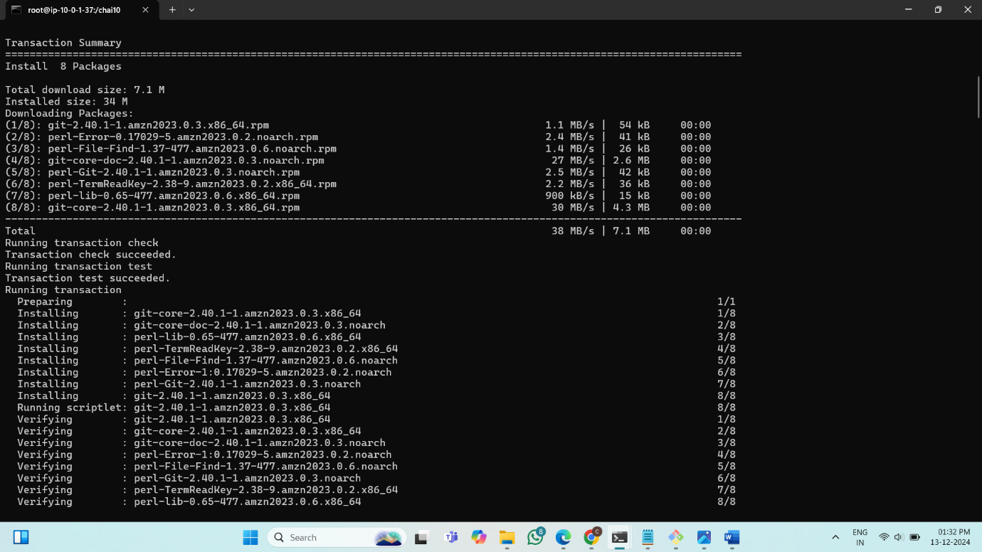

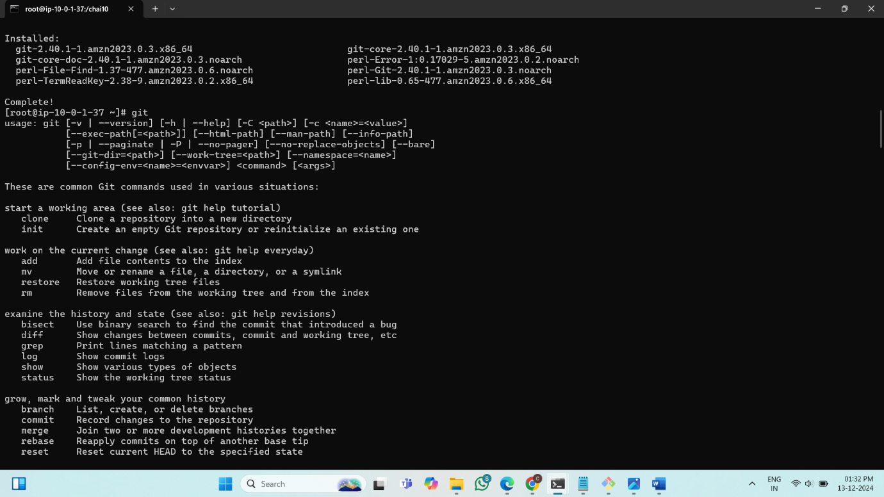

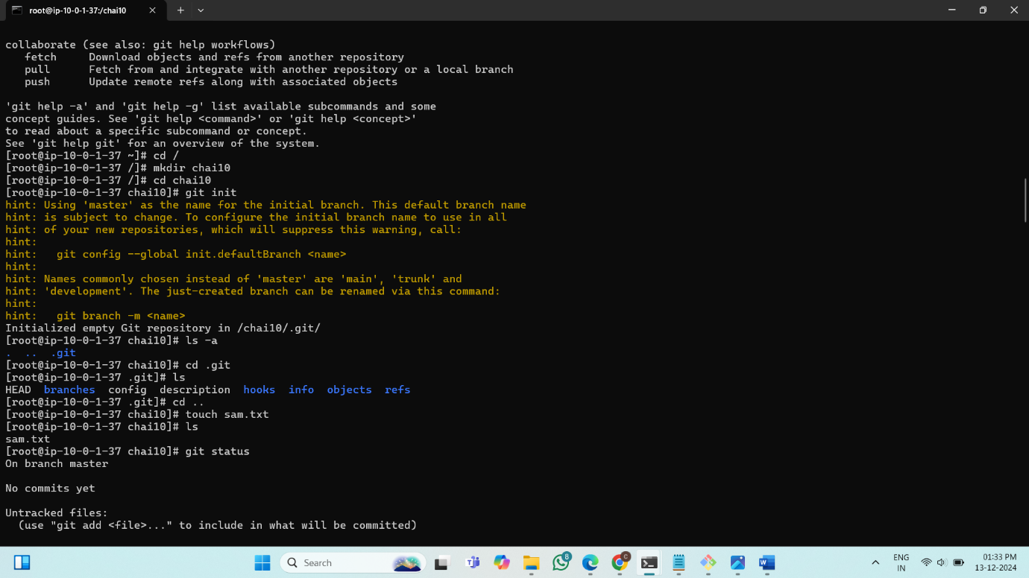

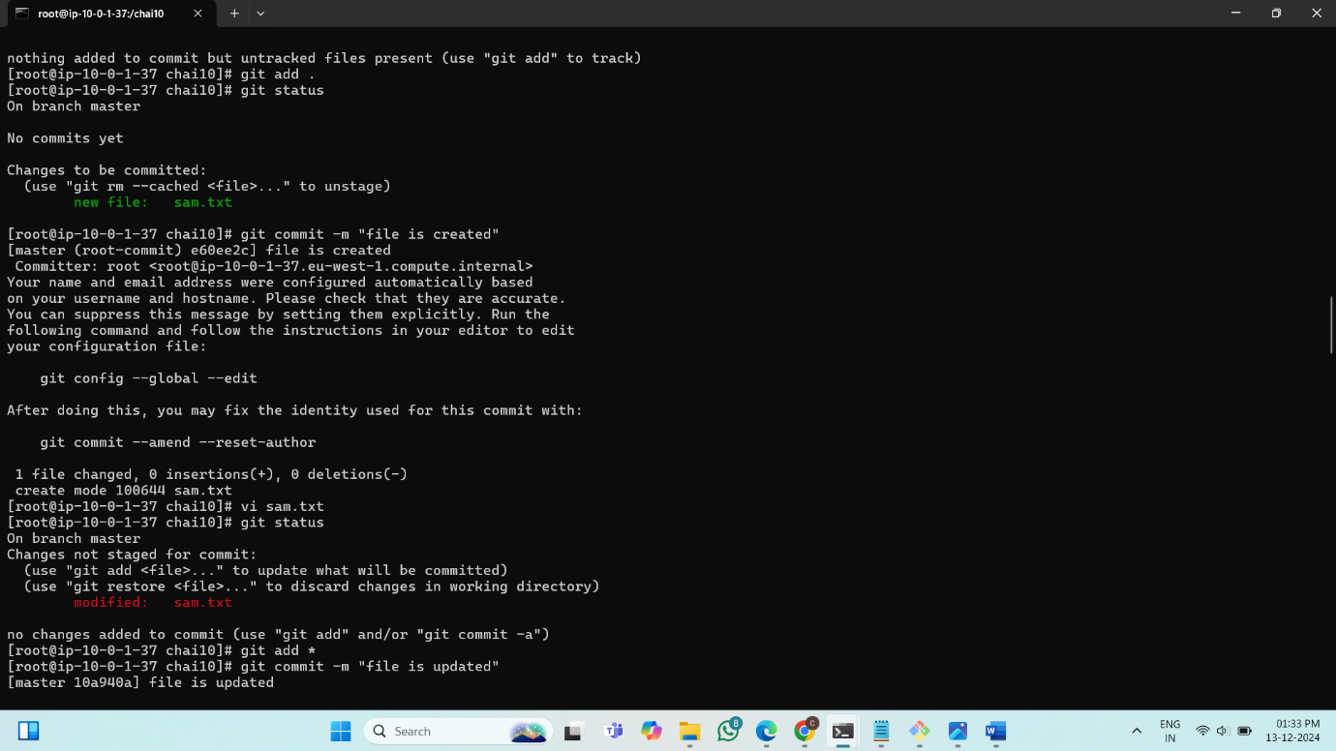

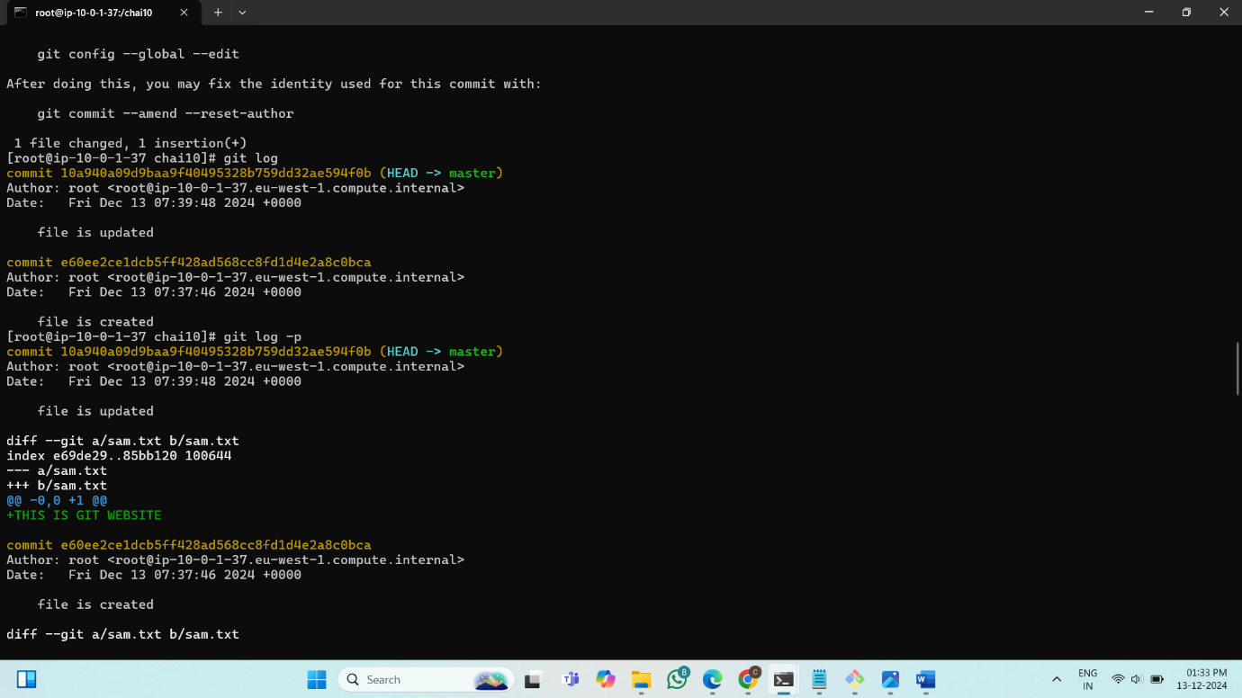

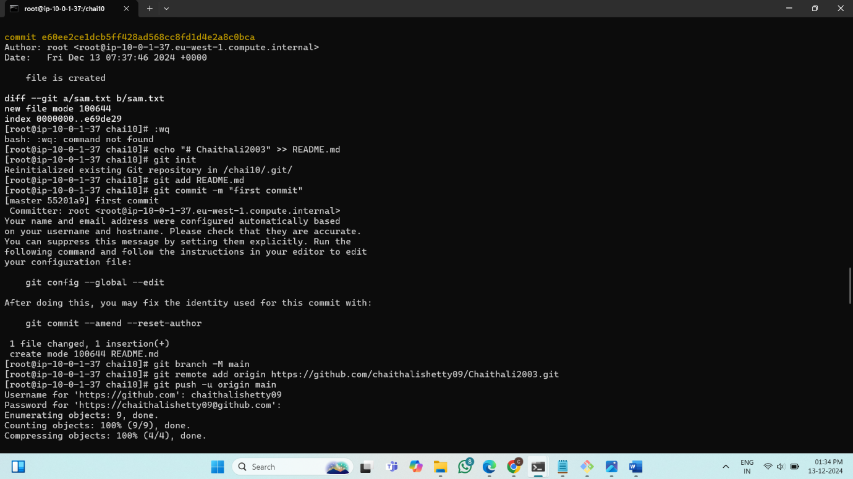

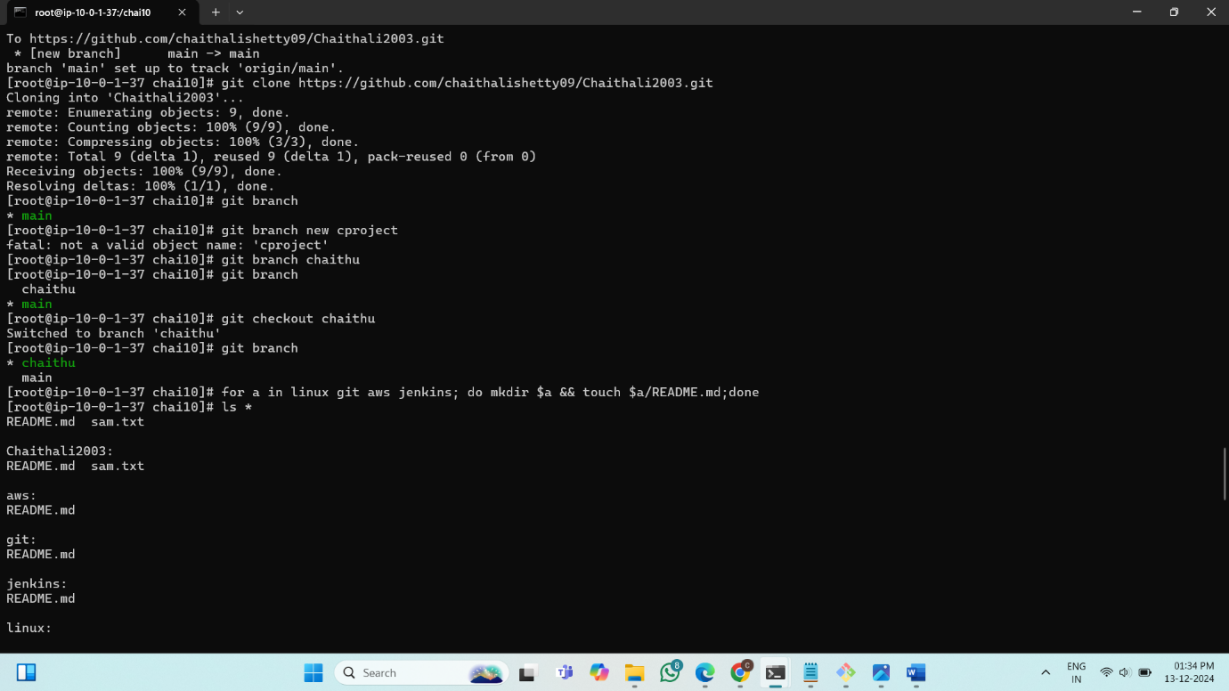

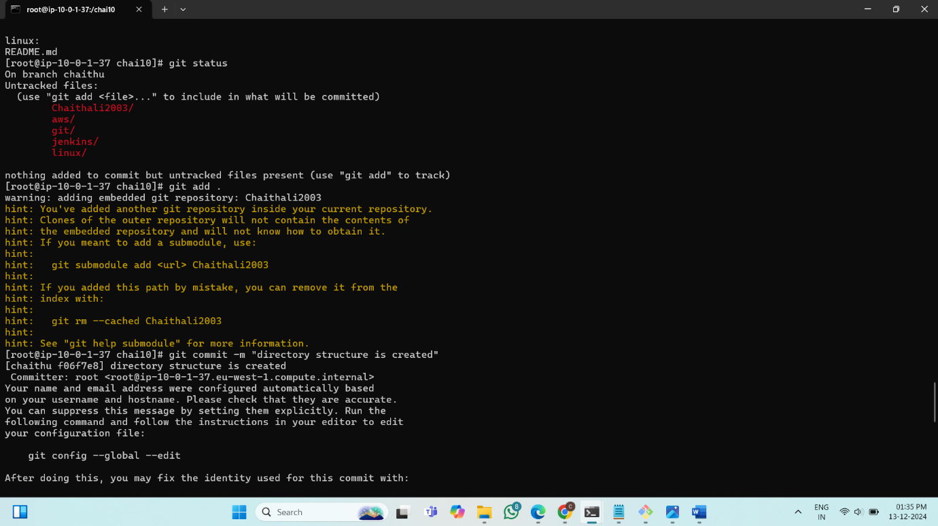

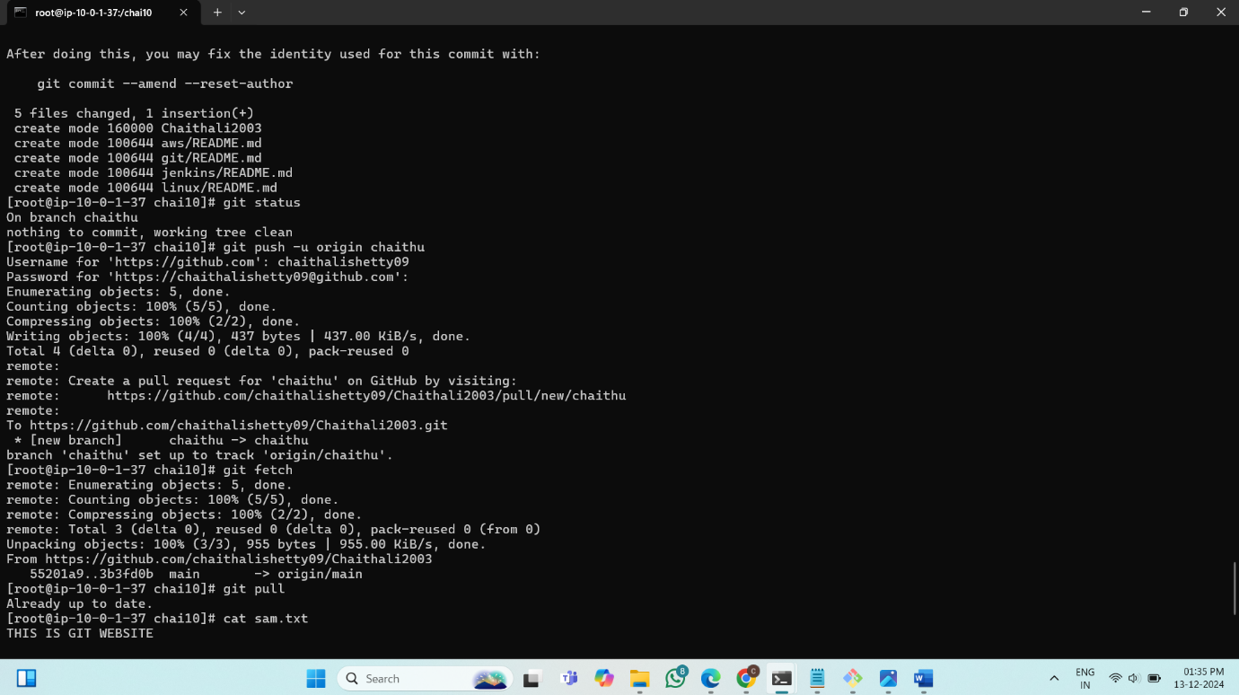

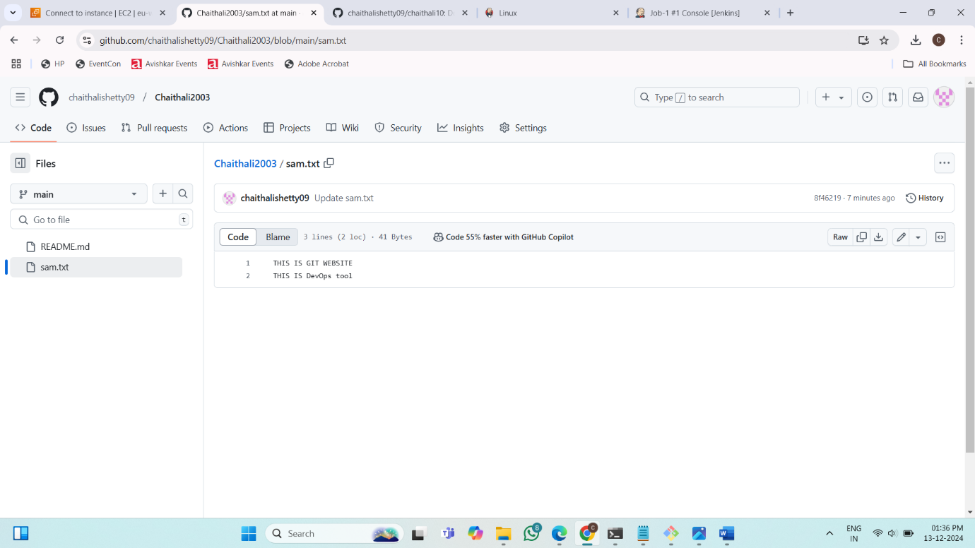

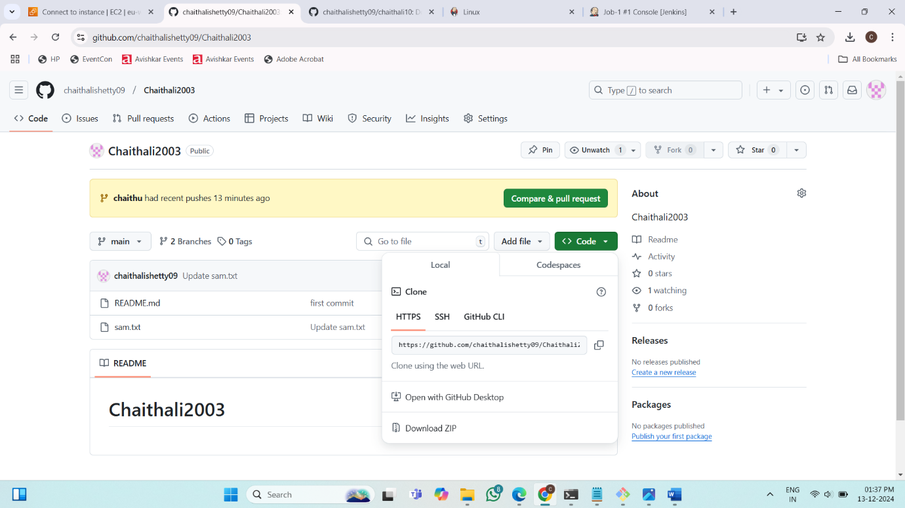

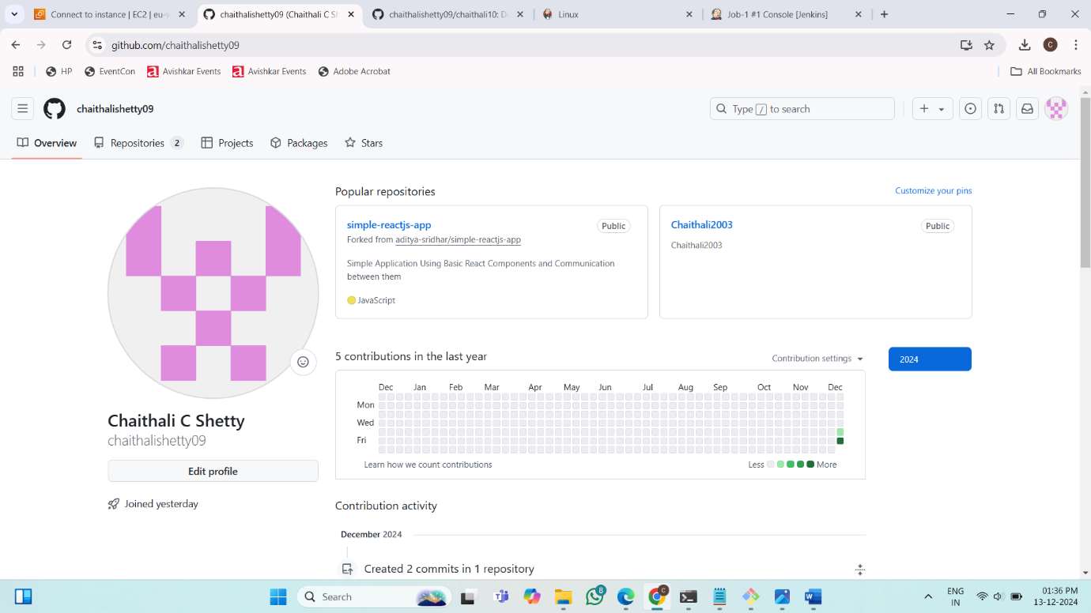

**Project 7: How to Download and Run Project from GitHub**

**Repositories: simple-reactjs-app**



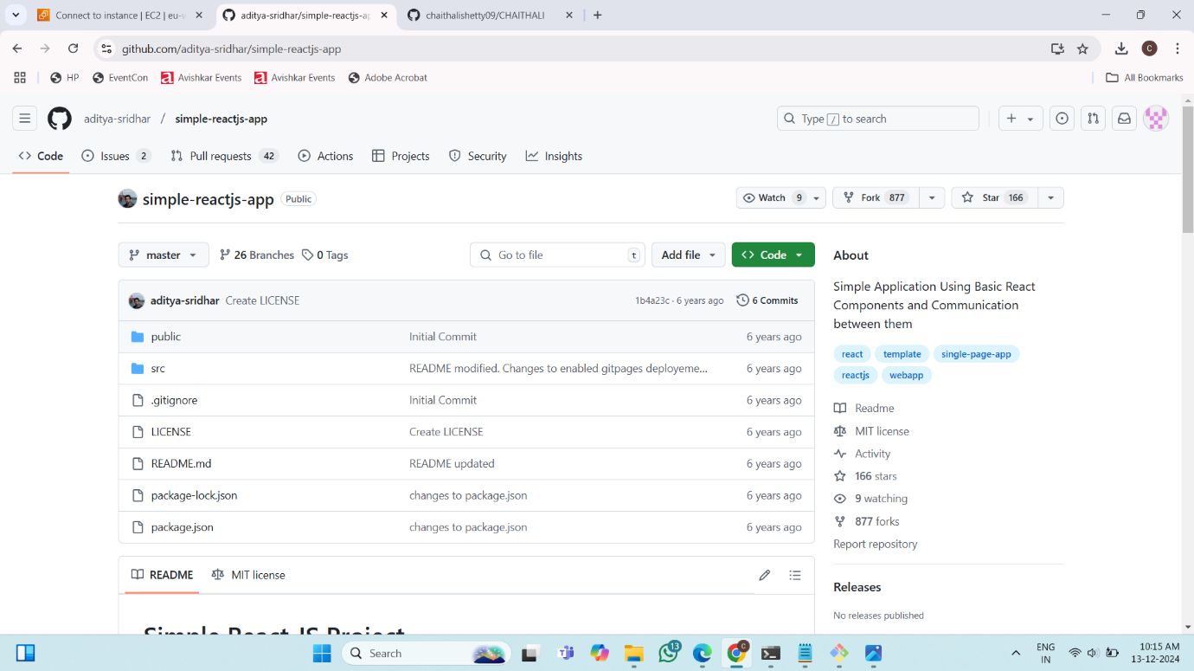

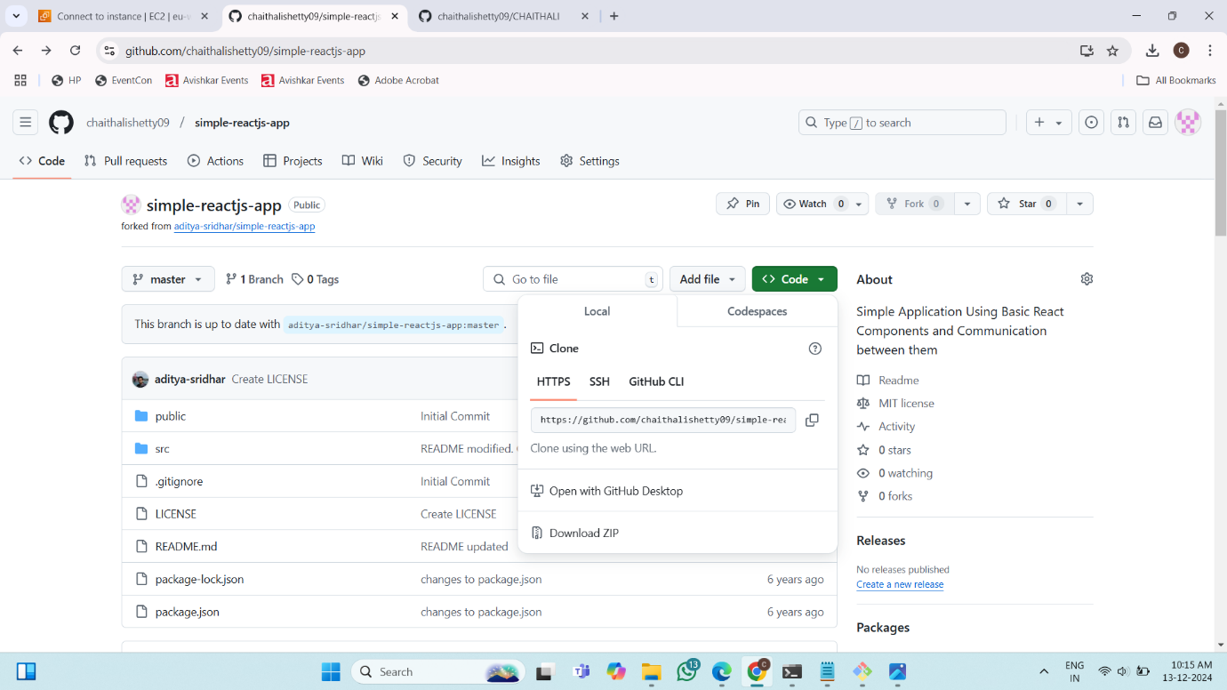

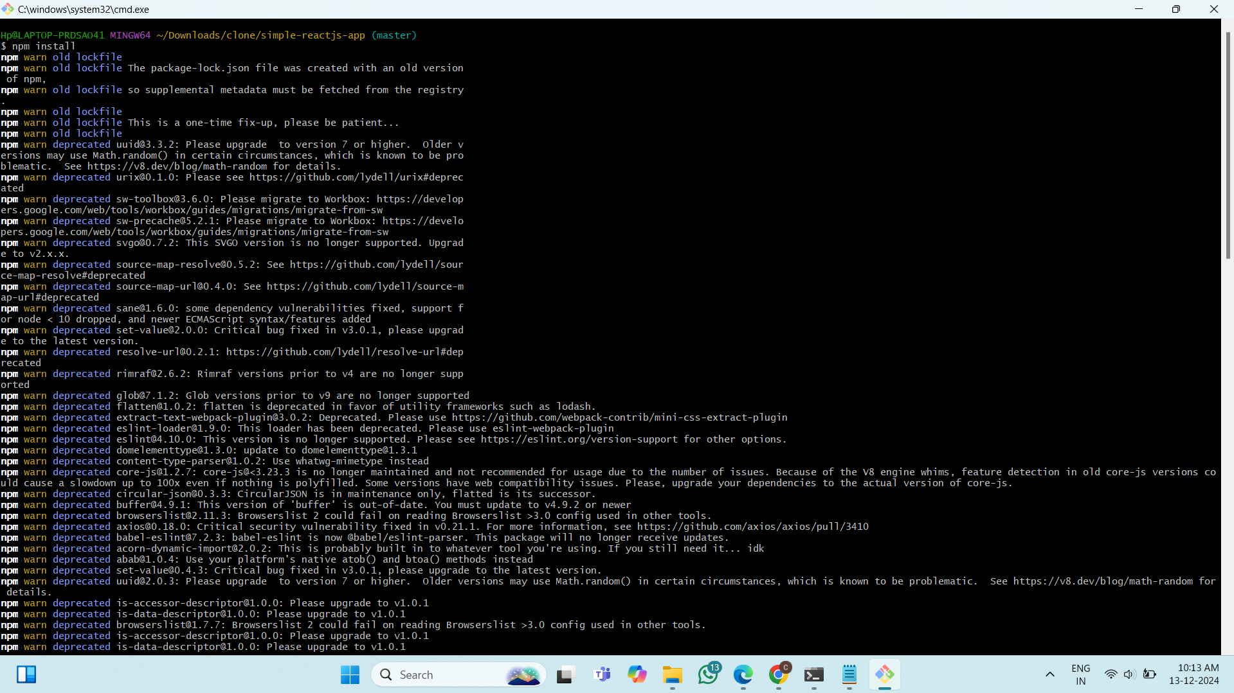

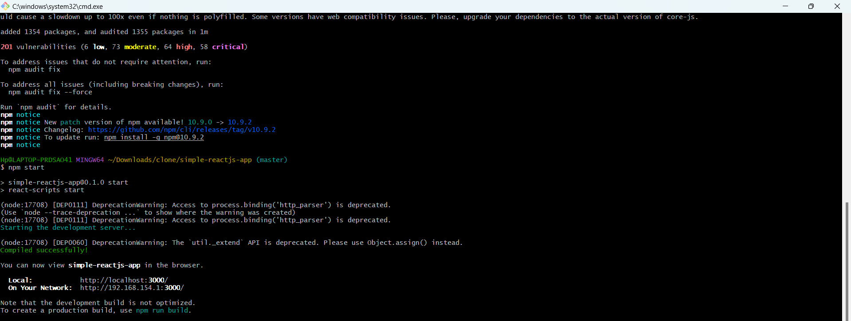

**Final Result:**

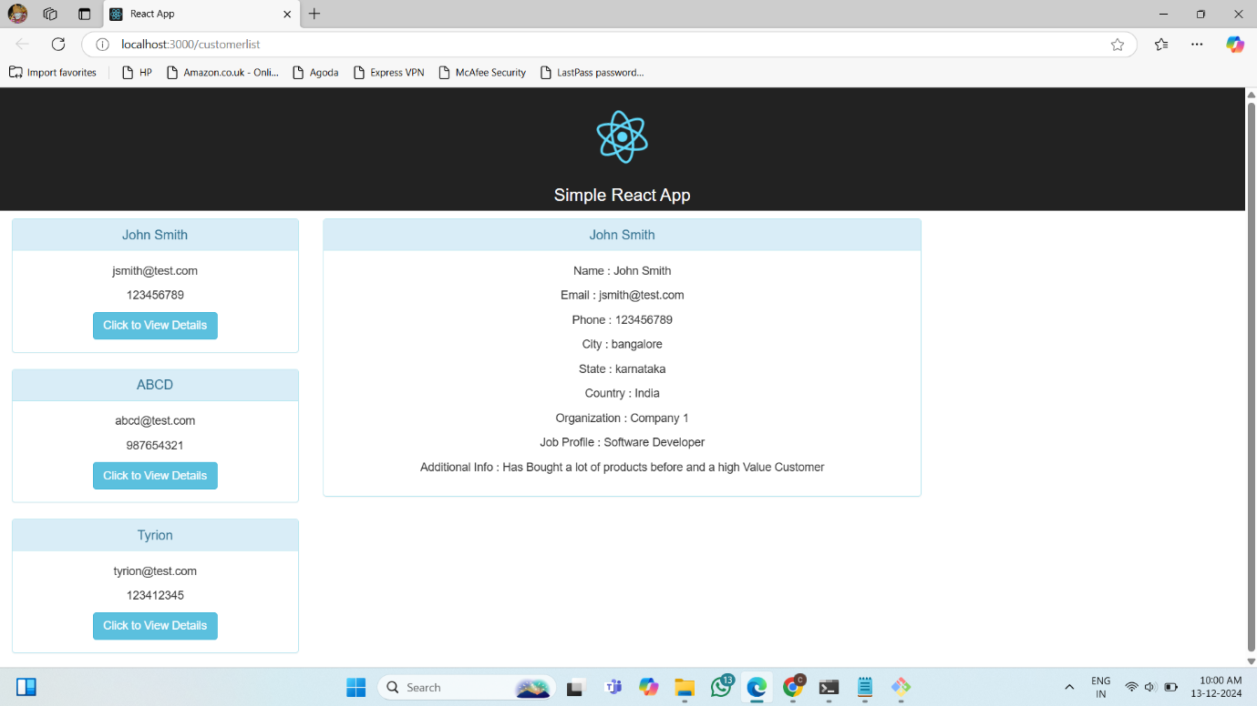

**Project 8: How To Automatically Trigger in Jenkins using pipeline script interacting with the GitHub**

**Creating the JOB-4-CHAITHALI:**

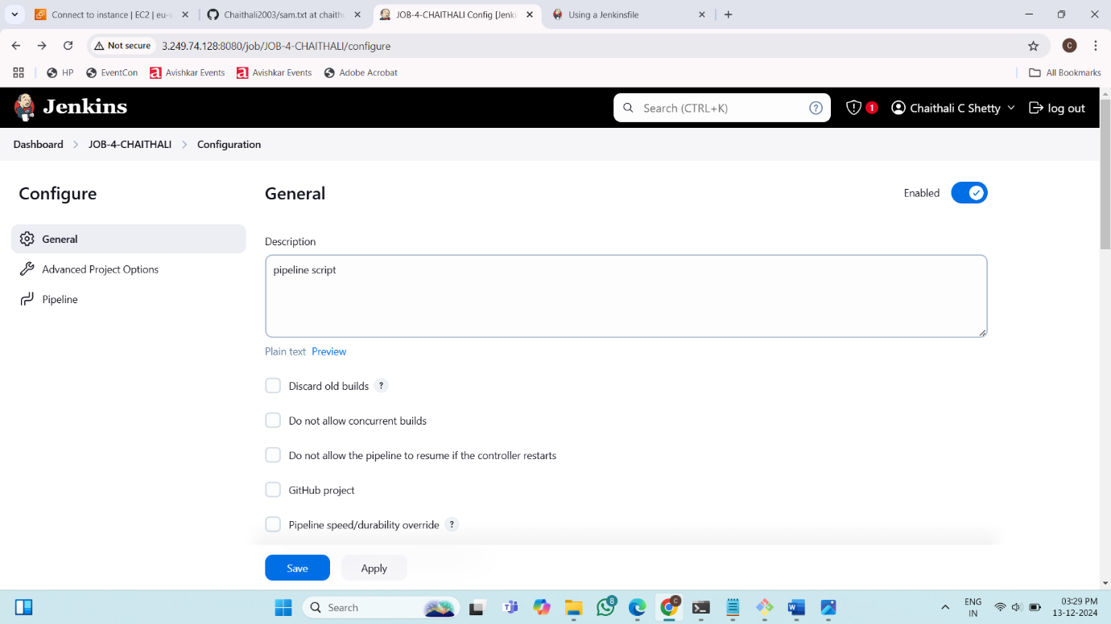

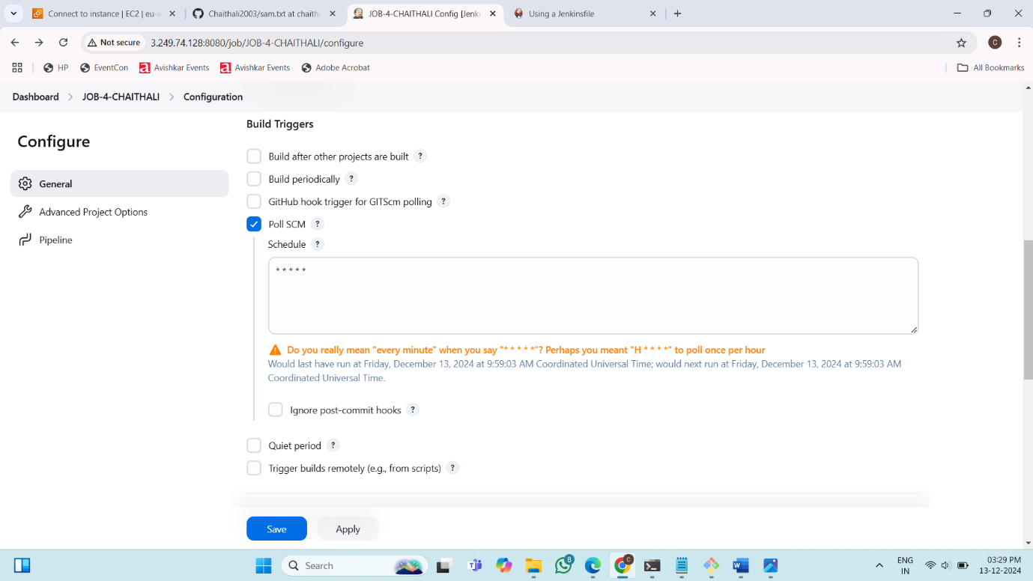

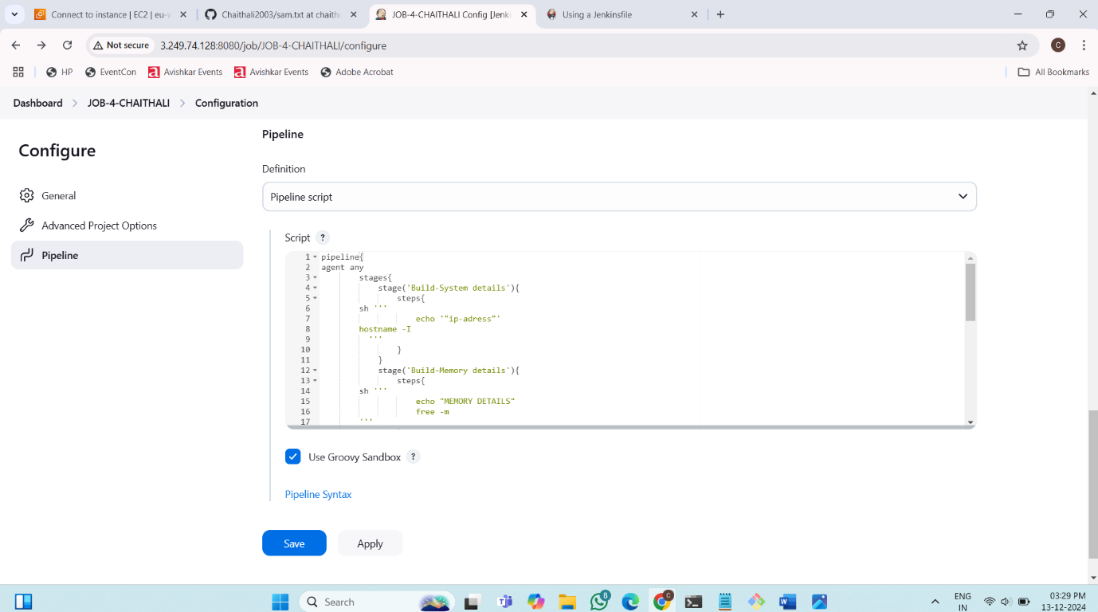

**Final Result:**

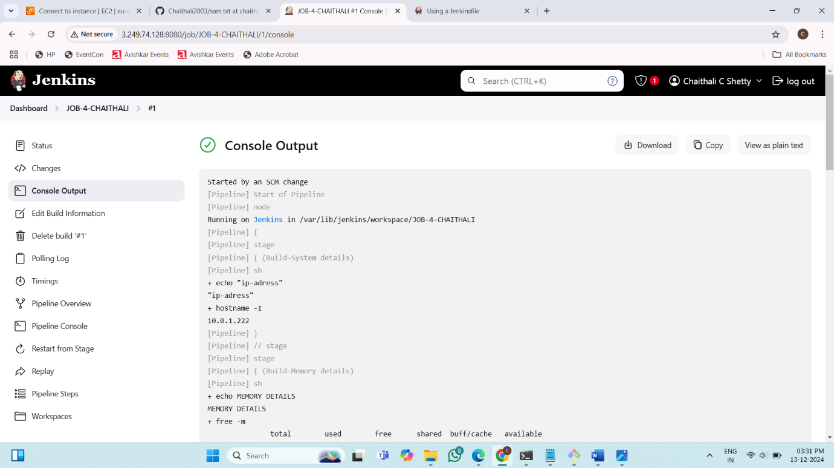

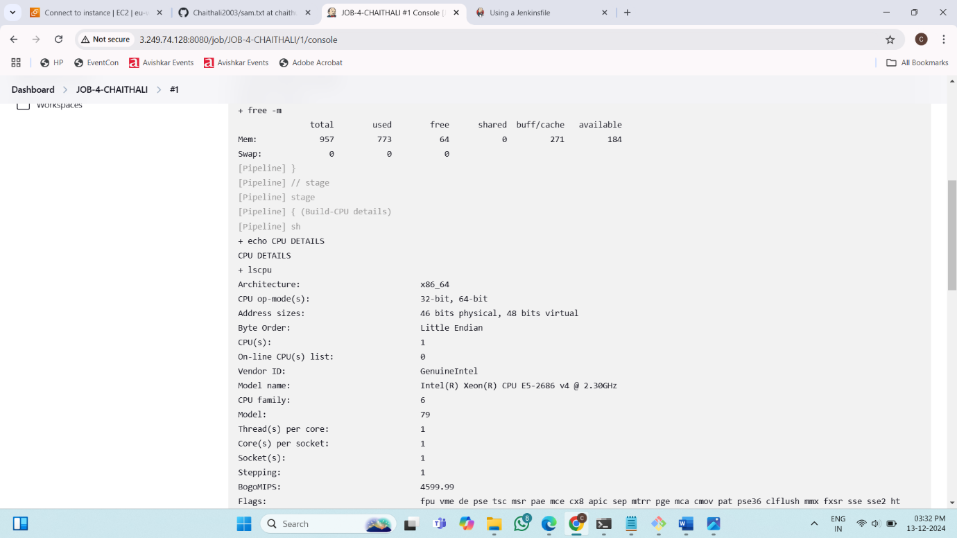

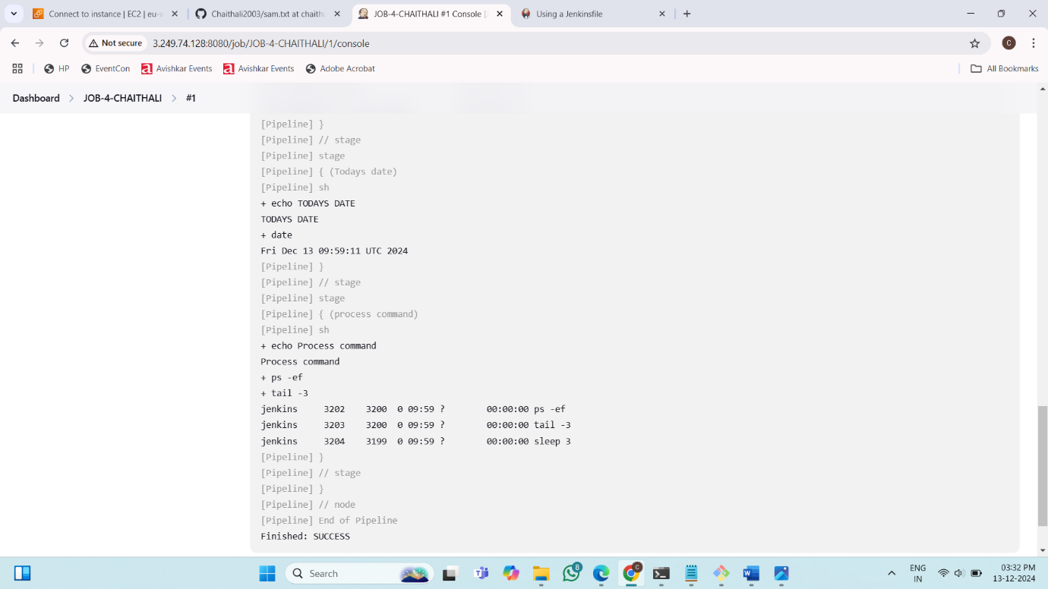

**Project 9: How to Clone with GitHub using Jenkins**

